ECP-2008-DILI-538025

Judaica Europeana

Evaluation report measuring the cross-border, multilingual and multicultural use
of JUDAICA resources

Deliverable number | D.5.2
Dissemination level | Public
Delivery date | 31st December 2011
Status | Final
Author(s) | Svenja Pokorny, Amitié


eContentplus

This project is funded under the eContentplus programme,
a multiannual Community programme to make digital content in Europe more accessible, usable and exploitable.
Table of Contents

1. The Purpose of Evaluation 3
1.1 The Approach 3
1.2 Participants involved in evaluation 5
1.3 The results 6
2. Event evaluation 7
2.1 Event 1 - Judaica Europeana Digital Humanities Workshop 2010 8
2.2 Event 2 - Judaica Europeana Conference (Education session) 11
2.3 Event 3 - Judaica Europeana Digital Humanities Workshop 2011 13
2.4 Event 4 - Annual Conference of the Association of European Jewish Museums (Workshop on Digitising Collections and Creating Virtual Exhibitions) 21
3. User feedback 27
3.1 Key Findings academic users 27
3.2 Key Findings teachers 37
3.3 Key Findings Academic Advisory Group 41
3.4 Those who found us 48
4. Multilingual, cross-border use of the Judaica content 49
4.1 Web statistics of special events: online exhibitions 50
4.2 Web statistics of the judaica-europeana.eu website 53
Annex I: Event Evaluation 2010 55
Annex II: Event Evaluation 2011 56
Annex III: Evaluation Questionnaire for scholars/researchers/teachers 58
Annex IV: Evaluation Questionnaire for the Advisory Academic Group (AAG) 60

1. The Purpose of Evaluation
The following evaluation report presents the results of a participatory evaluation process. The evaluation was conducted in the framework of Judaica Europeana with a particular emphasis on feedback from the users concerning the newly created online-service.
The purpose of the evaluation was to establish how the wide range of digital resources made available by Judaica impacts on the project target audiences and why and how they will use these resources.
This outcome-focused evaluation provides an opportunity to voice both criticisms and praise. It was conducted with (I) internal experts who have followed the project throughout its lifespan as well as with (II) external stakeholders.

1.1 The Approach
Evaluation of digital library services, based on user feedback, can take many forms depending on the objectives of the analysis. For example, usability testing often focuses on assessing the effectiveness, efficiency and/or satisfaction of the user experience with a particular interface. In our case the focus was directed on the outcomes and impacts of the service as suggested by the Association of Research Libraries (ARL). Usability System features such as technology performance were not considered.

products/services provided

ser
immediate achievements

ser
long-term achievements

ser
resources

inputs
outputs
outcomes
Impact
Input

EVALUATION

Fig. The results chain of a project

To measure the electronic resource value, we used the following criteria:
Usability – is the digitized resource an important addition to existing course/research material? Does it meet the expectations?
Completeness – do the digitized resources cover a topic appropriately?
Transferability – are the digitized resources suitable for teaching/research purposes?
Adaptability – can the digitized resources be adapted to on-line learning?

A set of shared questionnaires was developed and used by all project partners sometimes in a slightly customized and/or translated format. This procedure enabled the project to gather valuable information on Judaica target users, their interests, perspective needs and measure their reaction to the outcomes within a shared format.
As mentioned before, the evaluation was carried out internally with experts (members of the Academic Advisory Group) and externally with the help of potential end users (scholars, researchers, teachers, students).
Each partner was responsible for implementing the external evaluation whereas internal evaluation was carried out through the project co-ordinator.

The evaluation process started with evaluating events embedded in international conferences held during the two year lifespan of the project. Initially the events were more focused on methodological as well as technical aspects of digital humanities, whereas during 2011 the workshops and conferences showcased the outcomes of Judaica-Europeana as well as the lessons learnt especially in on-line exhibition design and production.

What  Subject of the evaluation | who  Involved end-users | VIA  Methodology and tools
Informativeness and consistency of the events presenting Judaica Europeana resources  CHAPTER 2 EVENT EVALUATION | Museum curators, librarians and archivists, post-graduates, academics, researchers, personal researchers, students, PhD students | External evaluation  questionnaire  Annex Ia/Ib
Quality, usefulness, transferability of the digital resources developed by Judaica Europeana  CHAPTER 3. 1  USER FEEDBACK | Lecturers, researchers, students and PhD students and in the area of Jewish studies, history, urban studies and other related disciplines: sociology, anthropology, literature | External evaluation  questionnaire  Annex II
Quality, usefulness, transferability of the digital resources developed by Judaica Europeana  CHAPTER 3. 2  USER FEEDBACK | School teachers and students | External evaluation  questionnaire  Annex II
Quality and consistency of the virtual exhibitions produced in cooperation with Europeana  CHAPTER 3. 2  USER FEEDBACK | Academic Advisory Group (AAG) | Internal evaluation/  questionnaire  Annex III
Fig. 2 Evaluation framework

1.2 Participants involved in evaluation
Extensive evaluation was conducted with:

- End-users of the products and services (e.g. virtual exhibitions, digitized content published on Europeana). The participants were recruited by partners from Universities and Schools. Two reasons were considered for the recruitment: a) the subjects needed to be familiar with the Judaica on-line resources; b) the subjects had to belong to the targeted audience for Judaica. Other subjects were involved during important dissemination events.
- Scholars and researchers in the area of Jewish studies
- Scholars and researchers in the area of urban studies and other related scholarly disciplines: art history, slavic and central-eastern European studies, history and literature.
- PhD students
- Holders and staff of collections of Jewish interest in Europe
- Staff and reference personnel in Jewish and other cultural heritage institutions in Europe
- Librarians and archivists
- Schools, teachers and students
- Genealogy interest groups
- Museum staff
- Expert from the Education Ministry

- Experts. In expert evaluation, as it is usually defined, the process and judgement components are assigned to a competent person who is neither a promoter, nor a producer of the project. Judaica Europeana established an Advisory Academic Group (AAG) to involve scholars in the effort to ensure high quality of the project results. The list of prospective members was drawn in consultation with the partners. The expertise of this group of scholars covers modern history, ancient history, Jewish studies and digital humanities as well as digitization of cultural resources. They are all potential end users. Members of the AAG (in alphabetical order) involved in the summative evaluation process were:
- Dr Francois Guesnet, Department of Hebrew and Jewish Studies, University College London, UK
- Dr Gadi Luzatto Voghera, Department of Historical Studies, Università Ca' Foscari di Venezia and Centre for Italian and European Studies, Boston University Padova Program, also Director of the Jewish Library and Archives in Venice, Italy
- Dr Laura Quercioli-Mincer, Department of Slavic and Central-Eastern European Studies, University of Rome, Italy
- Professor Antony Polonsky, Near Eastern and Judaic Studies, Brandeis University, US
- Dr Gerben Zaagsma, Yiddish studies, University College London, UK; currently at Huygens Institute, Royal Nederlands Academy of Arts and Science, The Hague

The task of the AAG was to provide critical feedback on the virtual exhibitions prepared in co-operation of Europeana and showcased on the Europeana portal.

1.3 The results
Concluding remarks are included at the end of most chapters. They summarize the range of divergent perspectives demonstrated in the comments and reflect the tone of the comments.

2. Event evaluation
Event evaluation was an important follow-up mechanism within the adaptive management framework of Judaica Europeana. It paid attention to participant engagement and response. Especially during 2011 it provided the partners with information on the quality of the major Judaica Europeana resources as perceived by the participants. It contains the lessons we have learned and should help us to understand:
- Whether the event was successful in terms of its objectives and impact
- What are the research interests of participating scholars
- What the participants got out of it
- What we have learned
- Key factors for improvement

Partners made great efforts to involve as much potential end-users as possible in local events but with an international audience. So a number of people from the main project target groups (staff in Jewish and other cultural heritage institutions in Europe, incl. museum staff, librarians and archivists, post-graduate students, academic researchers, family history researchers, PhD students, librarians, teachers, students) were introduced to the digital resources offered by Judaica Europeana and the repertoire of open source web-based research and teaching tools that are becoming a standard part of the toolbox of historians and other humanities researchers. They were asked to comment on the quality, usefulness and transferability of the presented resources. Throughout this evaluation responses were rich and varied.

Event 1 - Judaica Europeana Digital Humanities Workshop 2010
Event 2 - Judaica Europeana Conference (Education session) 2010
Event 3 - Judaica Europeana Digital Humanities Workshop 2011
Event 4 - Annual Conference of the Association of European Jewish Museums (Workshop on Digitising Collections and Creating Virtual Exhibitions) 2011

2.1 Event 1 - Judaica Europeana Digital Humanities Workshop 2010
Evaluation synopsis
This section presents the responses to the Evaluation form distributed during the Judaica Europeana Digital Humanities Workshop at the European Association for Jewish S Congress, held in Ravenna (IT) on 30 July 2010. A total of 11 completed forms were returned from a total registration of 30 people.

Rating Scale
A five-point scale was used to rate the quality of selected key aspects of the event (from 1=poor to 5=excellent).

 |  | Mean value
Content |  | (4.4)
Location |  | (4.1)
Speaker |  | (4.0)

Open questions (No answers or comments were excluded or edited.)

In one sentence, please describe your thoughts on this activity with respect to its value for you.
- It was extremely helpful and eye-opening.
- Giving more order to my “Spontaneous” activity on the Web – the beginning of, hopefully, an important networking with very different scholars.
- Very useful.
- Established the bases for digital research and research sharing.
- Opening new fields of activity for scholars of humanities, good advice for newcomers to this area.
- I would be happy to cooperate with Europeana and bring my museum’s resources to its collection. I am seeking any hints how to do it.
- Excellent introduction to this subject.
- I shall start to publish my research results in a digital form.
- More information, more structure
- For the first time I could form a clear picture of the possibilities and things involved in preparing a web-based critical edition.
- The workshop addressed crucial questions of how to use the web for research in the humanities, and I have received much inspiration.

What could have been covered more quickly, what needed more time, and what wasn’t covered?
- It was very effective and well balanced.
- Blank
- Blank
- Blank
- More time to [be given to] five examples for scholars with digitized projects already on the web, open source
- The process of digitisation was not covered at all – while this was THE thing that made me come here.
- The use of web tools in teaching such as Parmind needed more detailed presentation.
- Blank
- Blank
- The first part could have been quicker
- Could have been better presented. Also, the presenters were strongly biased towards a specific attitude towards web publishing (open access), which I do not share. Only actual authors of presentations should present, in order to avoid inability to answer questions from the audience. [one of the presenters was absent due to air strike]

Do you have any suggestions on how this activity could be improved?
- No
- It is an excellent introduction –next meetings could be longer and focus on one-two single cases. It would be advisable to sit at a round table.
- Blank
- Perhaps with the presentation of a specifically Judaic digital project.
- It has to be continued in small workshops within university and show very detailed how this will work
- I would like to hear much more real-life examples than pure theory which is not so much interesting
- If more time could be available, demonstrate a step-by-step setting-up of a collaborative research project on the web.
- Blank
- Longer workshop, more study-cases
- The acoustics of the room but that is something you could not really help – it’s the building.
- Blank

Other feedback or comments:
1. Blank
2. Concerning the use of the Web in teaching non-graduate students. It could be useful to draw few points – guidelines – recommendations regarding its honest use.
3. Blank
4. Blank
5. Produce together prototype of tutorial, demo-version of a topic with modern technology
6. Blank
7. One of the speakers should speak more slowly.
8. Blank
9. A very important initiative!
10. Excellent! Clear and good to follow for someone who is not so good in the technical aspects (like myself), thanks a lot.
11. Blank

Optional - Name:
- Ronit Yoeli - Tlalim
- Laura Mincer
- Blank
- Blank
- Blank
- Anna Lebet-Minakowska, Muzeum Narodowe w Krakowie
- Blank
- Maria Micaninova
- Blank
- Johanna Tanja
- Blank

Conclusions
Most participants appear to have been extremely satisfied with the overall organization and implementation of the workshop. The presentations were generally very well received and comments are enthusiastic and promising although there were a few criticisms. The acoustics of the high-ceiling room was one of the complaints mentioned by respondents. In terms of content, one participant wished for information on digitisation of museum collections, which is one of the objectives of the project, but not of the workshop. This misunderstanding can be easily solved via a direct contact with the interested person. The subject of on-line publishing was illuminating for some and controversial for others. There is quite an interest in the topic of collaborative on-line research and in participating in other similar workshops. Future events should include more practical guidance and real case studies or specific examples in Jewish studies.
The general consensus is that the first Workshop was a great success and a worthwhile experience for most participants.

2.2 Event 2 - Judaica Europeana Conference (Education session)
Evaluation synopsis
This section analyses the responses to the Evaluation form distributed during the Judaica Europeana Education session at the EVA/Minerva conference, held in Jerusalem (IS) on 16th November 2010 at the Van Leer Jerusalem Institute. A total of 12 completed forms were handed in at the end of the event.

Rating Scale
A five-point scale was used to rate the quality of selected key aspects of the event (from 1=poor to 5=excellent).

 |  | Mean value
Content |  | (4.0)
Location |  | (4.2)
Speaker |  | (3,7)
It must be underlined that the rating for the speaker is slightly distorted since some respondents underlined that they are not content experts and hence unable to rank the quality of the presentations.

What participants said (No answers or comments were excluded or edited.)

In one sentence, please describe your thoughts on this activity with respect to its value for you.
- Valuable because gives insights into innovation in an unfamiliar world
- It is valuable especially to educators
- This event was mostly teacher-oriented
- It is the valuable to know what is happening in the field. The moderator of the second section was excellent as were the speakers.
- A good overview of on area in which I am not involved.
- It was very interesting and helpful
- Learned a lot, very helpful contextualization
- The lectures were illuminating and interesting
- New and interesting
- It is very important to be exposed to practical projects that are connected to the content of the conference.
- I came specially and it was very good for me.

What could have been covered more quickly, what needed more time, and what wasn’t covered?
1. Adequate as “Trailers” for each presentation
2. Opportunities to the public.
3. It seems that the ideas that were suggested (proposed) are very interesting!
4. The lectures were good and to the point!
5. Blank
6. The time was well organized
7. Reaction from users: teachers, kids
8. /
Do you have any suggestions on how this activity could be improved?
- No
- Show and discuss project for the wide public and academia
- No
- /
- /
- /
- Have a newsletter about innovation in Education
- /
- The acoustics of the room but that is something you could not really help – it’s the building.

Other feedback or comments:
1. /
2. /
3. /
4. /
5. /
6. /
7. Thank you
8. How does the public get to it.

Conclusions
Participant feedback was consistently positive. The ranking was between good and excellent. The comments provide an insight into the participants’ assessment of the workshop. The introductive character of the presentation suited the audience well since some of the participants were not field experts or professional educators. The only reported problem has to do with the acoustics of the room.

2.3 Event 3 - Judaica Europeana Digital Humanities Workshop 2011
The Judaica Europeana Workshop on Digital Humanities was held to provide an introduction for scholars to the digital resources offered by Judaica Europeana and the repertoire of open source web-based research that are becoming a standard part of the toolbox of historians and other humanities researchers.

Evaluation synopsis
The Judaica Europeana Digital Humanities Workshop was held in London (UK) on 31st October 2011 at the Conference Centre of the British Library. A workshop evaluation form was included in each registration kit. 75 people attended the Workshop and a total of 40 completed forms were returned. It is assumed for the purpose of this evaluation review that the views expressed on these forms are broadly representative of all the workshop participants.

Rating
The responses to the question “How would you rate the event overall” (6-point rating scale ranging from very poor, poor, neutral, good, very good and excellent) are reported in the table below. The data reflects the satisfaction of the participants. The majority of respondents rated the workshop very favourably (67.5 % “excellent” or “very good” – the lowest score assigned is “good”).

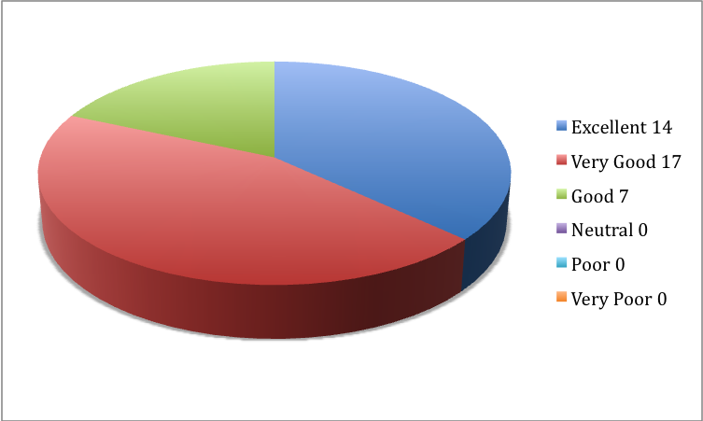
Fig. 1 Event rating

Main research and interest areas of respondents
- Medieval and post – medieval Judaica; archaeology of Jewish communities
- Yiddish literature
- Medieval science
- Jewish Contemporary History; 1848 and the Jews in Italy, Jews and families in the XIX Century
- Polish Jewish History, Jewish transnational anti-Jewish violence patterns, Sir M. Montefiore Archives
- Yiddish language, Yiddish folklore, literature, Hasidic Yiddish
- 2nd temple Judaism
- Digital domain, digital libraries
- Jewish studies
- Digital Humanities
- Hebrew Manuscripts, Hebraica and Judaica sources, Ladino sources
- Family History
- Jewish studies generally
- History and exhibitions
- German American Jewish Community – 1840s – 1940
- Library Electronic Resources
- History of Science – Medieval Arabic and Hebrew, History of Alchemy, Philosophy
- English Literature, library and information studies
- Sephardi Migrations post-inquisition- 1900
- Comparative European Cultural History
- Jewish History
- Jewish Historical and Genealogical Research
- Family and Community History; Information Literacy (and resulting issues)
- Medieval Jewish thought and teaching and Medieval Hebrew manuscripts
- Genealogy, mysticism
- Bible, Jewish Biblical Interpretation, Jewish liturgy
- Yiddish writers, political ideology; problems of translation
- Jewish, Yiddish Studies; digital humanities
- Judeo-Greek language and culture
- Digital humanities, archives, libraries, Jewish studies

Positions held by participants
Those participating in the workshop mainly hold positions within the academic system. Most are academic researchers and librarians.

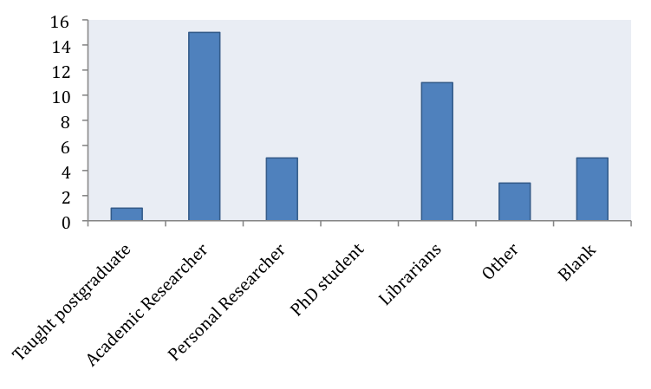
Fig. 2 Professional background

Question 1
How will the event affect your future work/research?

It can be deduced from the participants’ responses that the workshop introduced digital information resources, which were new to them and helpful for research and teaching. The presentations won over some technology sceptics and presented valuable information on digitisation issues. The participants summarize their learning gains as follows:

- Going to apply for internship with one of the projects. Will use research methods presented when working on PhD
- Became more sympathetic to technology
- Made aware of many new tools, resources, methods & technologies
- Introduced to useful tools, alerted to wider implications of digitisation
- Helped identify resources and networking
- Finding digital tools, assisting students getting information re Digital Humanities, digital projects & tools
- Widened view of digital research
- Awareness of facilities
- Opens up new sources of background data
- Updates awareness of digital humanities
- Will use tools and sources presented
- Excellent starting point to deepen & broaden our information about digital archive projects and future opportunities
- Will use site for both research and teaching
- Will direct visitors to more information as required
- Aware of more resources
- Hope it will help me to discover sources
- Improving general knowledge of research tools. Use of Judaica-Europeana website
- Provided a lot of information about digitisation projects and digitisation in general
- Material for teaching
- It has updated my digital knowledge greatly
- Better overview of activity and realities people are engaging with
- Improve access to digital resources, improve understanding and awareness of what is available
- Inspire
- Will help me in my work as a librarian
- Helpful re technical language, websites, tools
- Widen research and availability of resources
- Revealed new possibilities and networking
- New resources. Useful knowledge for submitting proposals
- New possibilities on DH and user engagement
- Some interesting suggestions on sites to consult
- Learnt about new tools for research. Ideas for online exhibitions.
Question 2
Is the material digitised by Judaica Europeana providing relevant information?

There is evidence from the workshop evaluation report that the participants value the information delivered because pertinent to their field of activity and/or research.

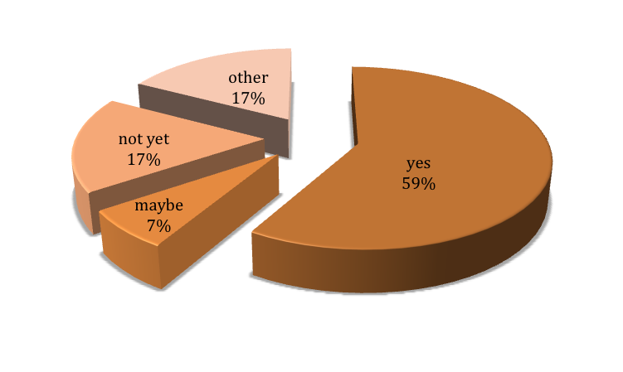
Fig. 3 Information relevance

Question 3
Are there any other resources concerning Jewish life in Europe you would like to see online?

Predictably, the “wish-list” for online resources reflects the interest and research areas of the respondents:
- Pre-modern Eastern European manuscripts
- Genealogical research
- Scans of as many medieval Hebrew manuscripts & incunabula [early prints].
- Images of shtetls [Jewish towns and villages in East-Central Europe before Second World War]
- Hebrew & Yiddish newspapers
- Hebrew mss in the British Library and important Judaica books
- Jewish archival material from German Laender Archives e.g. Bavarian State Archives
- Resources held in my institution
- Ladino-language printed sources
- Hebrew mss, Hebrew incunabulas, Yiddish rare books and serials
- The private archives of distinguished Jewish people
- Memory books of Jewish communities
- More Yiddish newspapers
- Leo Baeck College Library collections

Question 4
Are you going to use the material in Judaica Europeana digital collections in your research?

Most respondents have very concrete ideas on profitable ways to use the information gained in their research and work context.
- Yes
- The sort of materials needed are not yet available
- As sources
- Background resources for genealogical & historical research
- Images of Judaica Europeana serve as examples in school projects of Jewish tradition and religion
- Places, themes etc.
- Samples of Judaica German archive material for comparative studies
- No
- To provide a background of fact, illustrating the era/conditions in which my families evolved in Europe
- Not sure. Will take a closer look at material
- Will consider adding link to Judaica-Europeana website
- To contextualise teaching on the Holocaust
- Inform visitors of the wider knowledge on the web
- It depends on what I find
- By transferring it to the British Library users
- For museum projects
- I hope so
- For new research on South East Europe and Jews from 1848 to the great depression
- Yes, I don't know yet
- Have not yet investigated
- Yes
- Hope to be able to use Judaica Europeana in researching British Museum Judaica, objects from Jewish communities in Europe, exploring the individuals and communities from which the objects originated. Results of research would be available on the British Museum collections online database
- Yes, in seminars for history students
- Will link to site through web resources and direct researchers
- Likely research
- Need to examine the site further
- Yes, for research, teaching, as part of Library service

Conclusions
The evaluation revealed the Judaica Europeana Digital Humanities Workshop was very successful in terms of achieving its objectives.
The main objective of the Workshop was to help the project achieve its dissemination goals to target audiences. The Workshop succeeded in extending the project’s outreach. It attracted a varied audience of scholars, librarians and digital humanities professionals. In addition to the 75 people who were able to attend the Workshop, many more were introduced to Judaica Europeana by receiving the programme. The announcement and programme tweeted by the British Library received over 800 ‘I like this tweet’ votes. A majority of the participants requested to be put on the subscription list for Judaica e-Newsletters.
The Workshop had a positive impact on participants by introducing them to Judaica Europeana resources and other new online resources to be used for research and teaching.
The Workshop was effective in improving participants’ knowledge related to digital humanities, positively affecting attitudes towards new technologies.
The feedback forms gathered provided valuable information on users, their interests and needs.
The event organizers were confirmed in their approach that the programme needed to present a balance between presentations on Judaica European resources and more general presentations on cutting edge developments in digital humanities.

Participants (in alphabetical order)

- Alpert Michael - Professor Emeritus, University of Westminster.
- Anderson Sheila – Centre for e-research King’s College London
- Baker Colin – Head of Near and Middle East Collections, British Library
- Baraimov Dana - Rothschild Foundation Hanadiv Europe
- Barnett Ilana - Documentation Assistant Royal Air Force Museum
- Boeckler Annette M Dr. - Scholar Librarian and lecturer Leo Baeck College Library
- Bosek Robert Dr
- Catalan Tullia Dr - assistant professor in the University of Trieste, Jewish Contemporary History DISCAM-Dipartimento di Storia e Culture
- dall'Antichità al Mondo Contemporaneo
- Clark Chris – Head of Digital Research, British Library
- Cohen Dr Susan
- Cream Naomi
- Davis Barry - lecturer in Modern European History at Kingston and Warwick Universities and the University of West London and teach Jewish History and Yiddish Language at the London Jewish Cultural Centre
- Diamond Judith - Jewish Genealogy
- Feldman David – Director Pears Institute for the study of Anti-Semitism School of Social Sciences, History and Philosophy Birkbeck
- Ferrario Gabriele Dr - Research Associate at the Genizah Research Unit Cambridge University Library.
- Freedman Vanessa - Hebrew & Jewish Studies Librarian UCL Library Services
- Frood Margaret - Family and Local History
- Gogel Sandra Dr - Gogel Family Judaica Collection Paris.
- Grodzinski Vera Dr, researcher
- Guesnet Francois – Department of Hebrew and Jewish Studies, University College London
- Harris Rachel – University College London
- Haskel Carol – European Association for Jewish Culture
- Hawkins Dr. Richard - Senior Lecturer Department of History University of Wolverhampton
- Heuberger Rachel – Frankfurt University Library
- Hogan Margaret - Secretary of the Irish Jewish Museum in Dublin
- Christian Jensen, Head of Arts and Humanities, British Library
- Jones Huw - Foundations Digital Library project, Cambridge University Library
- Kerbel Jack
- Kerbel Sorrel Dr - independent researcher, ex-university lecturer, and editor of the library reference tome, Routledge Encyclopaedia of Jewish Writers of the Twentieth Century.
- Kerziouk Olga – Slavonic and East European Collections
- Koch, Ulrike – Cataloguer, British Library
- LeForest James - librarian with a master's in Jewish Studies from
the Spertus Institute of Jewish Studies, Chicago
- Leopold Joan Dr
- Lubell Stephen - PhD Student the Institute of English Studies School of Advanced Studies the University of London
- Luszczynska Magdalena - A graduate of Hebrew and Jewish Studies, UCL, currently postgraduate programme in Digital Humanities, UCL
- Mahony Simon - Teaching Fellow UCL Centre for Digital Humanities
- Department of Information Studies University College London
- Maoz-Michaels Dahlia - Judaica librarian
- Marmorstein Yissochor - Hebrew/Yiddish/English and researcher, specialising in Jewish genealogical research from printed and manuscript sources
- Merchán-Hamann Cesar - Muller Library/Bodleian Library Hebraica Curator
- Michaela Meiser - Acquisitions Librarian Wiener Library Institute of Contemporary History
- Nenk Beverley - Curator Medieval Collections and Judaica Department of Prehistory and Europe British Museum
- Nobel Robin - Robin Nobel Programme Grants Officer Academic Jewish Studies and Jewish Heritage Grant Programmes Rothschild Foundation Hanadiv Europe
- Paluch Agata - PhD student from UCL Hebrew and Jewish Studies Department
- Paskin Sylvia – Lecturer London Jewish Cultural Centre
- Purday Jonathan – Senior Communications Adviser, Europeana
- Rabin Zvi - Librarian Liubavitch Lending Library
- Rajak Tessa - Professor of Ancient History Emeritus University of Reading Senior Research Fellow Somerville College Oxford.
- Rauxloh Simone – writing a book regarding the lives of German Jews
- in London.
- Rodriguez Josefina - The Warburg Institute
- Rogatchevskaia Katya – Lead Curator, Russian Studies
- Salinger Peter
- Sambrook Katie - Special Collections Librarian King's College Foyle Special Collections Library
- Sandman Israel M. Dr - Department of Hebrew and Jewish Studies University College London
- Sayce Elizabeth
- Schwarb Gregor - Senior Research Associate The European Research Council’s FP 7 Project “Rediscovering Theological Rationalism in the Medieval World of Islam” Research Unit Intellectual History of the World Institute of Islamic Studies, Freie Universität Berlin
- Seeley Mary - Assistant Librarian (History & Religions, Ancient Near East, Semitics & Judaica) Teaching and Research Support (Library) School of Oriental and African Studies
- Seely Philip - , Designation Co-ordinator Heritage Protection & Planning Group, English Heritage
- Selby Elizabeth – Jewish Museum London
- Shepherd MA Dr - writing and researching a book on interactions between Gentile attitudes to Jews and Jewish attitudes to Gentiles in UK and France 1770-1860
- Slataper Matteo - Università di Trieste
- Solomon Norman Dr - The Oriental Institute, Oxford University
- Stanley-Clamp Lena - Director, European Association for Jewish Culture, London
- Project Manager, Judaica Europeana
- Summers Anne (Dr) - Honorary Research Fellow Birkbeck College
- Tahan Ilana – Lead Curator, Hebrew Collection, British Library
- Tanner Simon – Digital Consultancy Services, Kings College London
- Vogler John – Researching family members Vogler, Hess and Frayber
- Wartenberg Ilana Dr - Department of Hebrew and Jewish Studies, UCL
- Watson Lena
- Yerushalmi Eva
- Yerushalmi Yack
- Zeidler Milena - Muller Library Oxford Centre for Hebrew and Jewish Studies
- Assistant Librarian
- Zaagsma Gerben - Huygens Institute for Dutch History, The Hague; editor, European History Primary Resources
- Zmroczek Janet, Head of European Studies, British Library
- Zucker Mordechai, researcher at Rothschild Archive, London

2.4 Event 4 - Annual Conference of the Association of European Jewish Museums (Workshop on Digitising Collections and Creating Virtual Exhibitions)
The workshop Digitising Collections and Creating Virtual Exhibitions was held in occasion of the Annual Conference of the Association of European Jewish Museums which took place in London (UK) from the 19th to the 22nd November 2011. A workshop evaluation form was included in each registration kit. 41 professionals from 35 different museums across Europe participated and a total of 20 completed forms were returned. It is assumed for the purpose of this evaluation review that the views expressed on these forms are broadly representative of all the workshop participants.

Rating
Most participants appear to have been satisfied with the workshop. On the evaluation form where participants were asked to give their overall workshop rating in terms of usefulness, 70% of the respondents selected either “excellent” or “very good”.

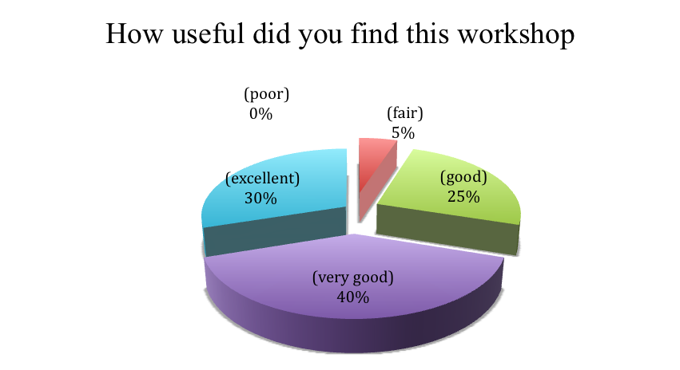
Fig. 1 Event rating 1

Is the digital content on Europeana useful for your museum?
Museum operators definitely value the digital content displayed by Europeana. Even those who select “no” do not challenge the service, but underline that they are not in the condition to form an opinion because they have just learnt about its existence. For museum professionals, Europeana very much functions by “peer reviewing”. Respondents appreciate that they can find out more the about the activities, digital collections and on-line exhibitions of other museums. The clearly perceived benefits are: resources for educational purposes, material for future exhibitions and know-how for museum management in general.

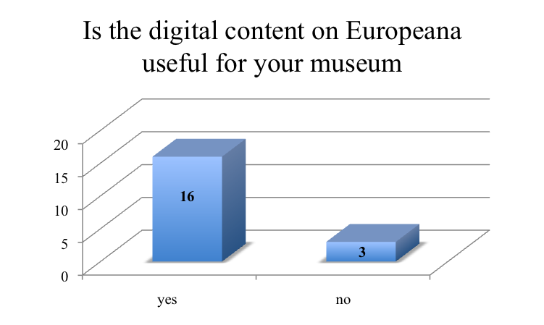
Fig. 2 Assessment of the usefulness of digital content available on Europeana

Comments:
- This needs further exploration
- We can use its experience; research comparison
- Research for exhibitions collections, educational purposes
- Useful knowledge for future exhibitions
- (No) I did not use it yet - I have to check
- Allows us to see what is available in Jewish museum sector and see how we might put our collections to use
- (No) It will be
- (No) I have to think about it
- Honestly I haven't heard about it before, but as far as I understand it will be very useful for my museum
- It is useful for any museum in its work
- Any additional information is useful for collections research
- No because I am in America
- Use as a guide, an example of what is done elsewhere

Do you have collections already digitised concerning Jewish urban life, Jewish expressions in the European urban space or Jews as urban celebrities that could contribute to the Judaica project?
A wealth of material in museums still remains undigitised. A number of digitisation programmes are announced. One of the identified obstacles to digitization remains copyright. Some of already available digitized resources indicated by the respondents (e.g. Dreyfus’ case) would present an interesting content for Judaica.

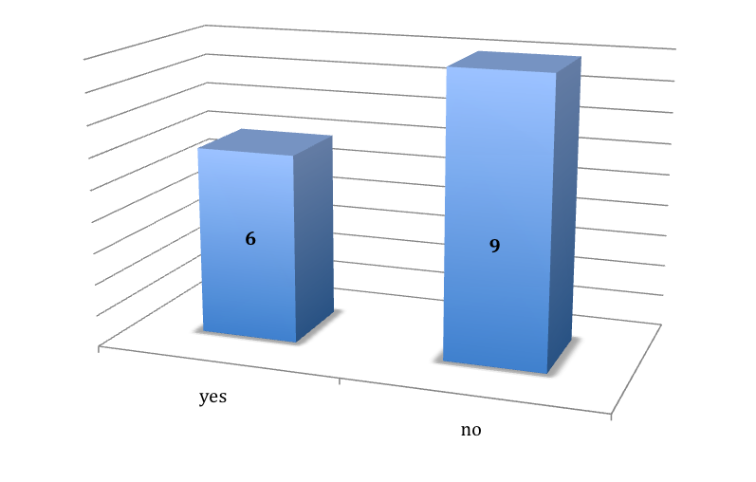
Comments
- (Yes) photos and objects
- (No) hoping to start with
- Not yet
- In process
- Work in progress
- (Yes) especially a complete collection of 3000 objects related to the Dreyfus’ case
- Not yet digitised, but we could contribute with European objects from our collections
- (Yes) but we have not yet solved the copy right issue
- For some particular scholars

If "NO" to the above question, do you have plans to digitise your collections now or in the near future?
According to the responses consistent digitisation activities are envisaged for 2012.

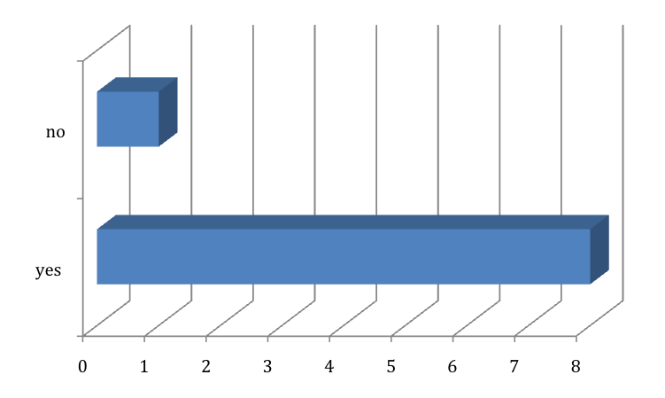
Comments:
- Next year
- We are working on digitisation and hope to link to JE project as soon as we can
- The project will start in 2012
- We will continue it
- We hope so but we are not sure
- Only partly

How useful was the information provided in the Virtual Exhibition presentation?
For museums professionals the possibilities of producing Virtual Exhibitions was eye-opening and inspiring. The presentation shed new light on how audience engagement can be achieved. Probably time was not sufficient to go into detail about technical requirements for the on-line exhibition design process. However the workshop enabled the participating museum professionals to come up with new exhibit ideas.

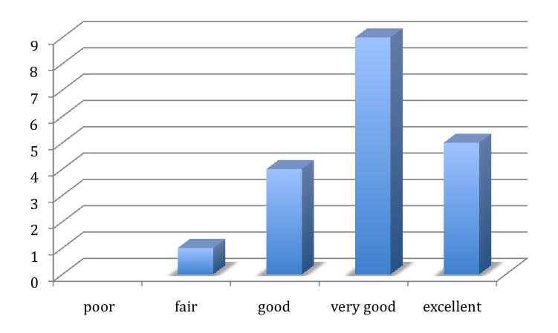
Comments
- (Excellent) never did before - perhaps plan a virtual exhibition
- (Fair) not very much given the limited time
- (Good) I expected more practical information

Would your museum be interested in working on collaborative online exhibitions with other European Jewish museums?
Results clear show that collaborative forms of exhibition design are of interest for museum professionals. One senses caution in the comments but the positive response rate is promising.

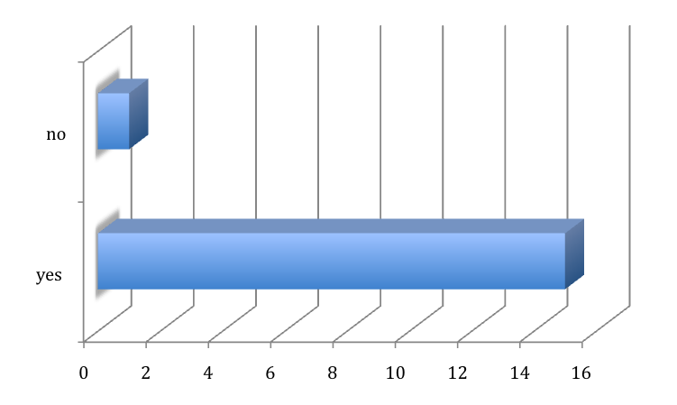

Comments
- I can't say
- Not at that time - may be later
- Yes - we are currently collaborating with the Prague Jewish Museum
- If resources allow
- Yes, but it depends on the topic and conditions
- Yes, I'd like to. On historical/pedagogical topics such as: Jewish History
- It depends on specific exhibition scheme/ project
- Eventually yes

Conclusions
Currently a paradigm shift is on-going in the museums world. For example museum websites are less “about” museums but “become” the museum in digital form . The trend is led by a limited number of forerunners, innovative institutions on the edge. The reality of especially smaller museums is quite different. The very positive reaction to the event evidences that museum staff is eager to know more about ways that make museum collections and experiences accessible and participatory online. The use of concrete examples and the presentation of a first hand experience brought a virtual experience closer to them. The new perspectives stimulated the spirit of experimentation and innovation of some and increased general understanding of others.

3. User feedback

3.1 Key Findings academic users
In its 2011-2015 Strategic Plan, Europeana announced new ways for end users to participate in cultural heritage, to be one of the primary tracks by which the organization will deliver value. Europeana intends to enhance the user experience and offer services that allow users to interact and participate. This is why Judaica Europeana decided to carry out end-user evaluation with extensive consumers of digital resources – here lecturers, researchers, students and PhD students and in the area of Jewish studies, history, urban studies and potentially other related disciplines: sociology, anthropology, literature.

The Jewish Museum in London conducted two workshops (3rd and 15th November 2011) with university level groups. Two university level groups were invited to the museum to participate in a dedicated workshop, where both groups could learn about the project and how to use the portal as a resource for their research. An educator and the Judaica Europeana project officer led both groups. The other partners contacted scholars individually and invited them to evaluate the digital resources remotely from their computers. All were strongly encouraged to review the digitized collection most relevant to their needs. The feedback was collected by a questionnaire. They provide candid opinions from academics as well as information about their motivations, feelings and attitude.

Involved academic users
1 – Student, Parkes Institute for the study of Jewish/non-Jewish relations, Course lecturer: Joachim Schloer, University of Southampton
2 – Student, Parkes Institute for the study of Jewish/non-Jewish relations, Course lecturer: Joachim Schloer, University of Southampton
3 – Student, Parkes Institute for the study of Jewish/non-Jewish relations, Course lecturer: Joachim Schloer, University of Southampton
4 – Student, Parkes Institute for the study of Jewish/non-Jewish relations, Course lecturer: Joachim Schloer, University of Southampton
5 – Student, Depart. of Hebrew and Jewish studies, Course ‘Jews in English speaking lands’, Course lecturer: Michael Berkowitz, University College London
6 – Student, Depart. of Hebrew and Jewish studies, Course ‘Jews in English speaking lands’, Course lecturer: Michael Berkowitz, University College London
7 – Student, Depart. of Hebrew and Jewish studies, Course ‘Jews in English speaking lands’, Course lecturer: Michael Berkowitz, University College London
8 – Student, Depart. of Hebrew and Jewish studies, Course ‘Jews in English speaking lands’, Course lecturer: Michael Berkowitz, University College London
9 – Student, Depart. of Hebrew and Jewish studies, Course ‘Jews in English speaking lands’, Course lecturer: Michael Berkowitz, University College London
10 – Student, Depart. of Hebrew and Jewish studies, Course ‘Jews in English speaking lands’, Course lecturer: Michael Berkowitz, University College London
11 – Student, Depart. of Hebrew and Jewish studies, Course ‘Jews in English speaking lands’, Course lecturer: Michael Berkowitz, University College London
12 – Michael Berkowitz, Professor of Modern Jewish History, Department of Hebrew and Jewish Studies, University College London
13 - Joachim Schlör, Professor of Modern Jewish/non-Jewish Relations, University of Southhampton
14 - Michael L. Miller, Assistant Professor in the Nationalism Studies Program, Central European University, Budapest
15 - Vera Dancz, Researcher
16 - Janka Szakonyi, Jewish Family Research Center, Budapest
17 - Botond Kertész, Lutheran Museum, Budapest
18 - Szonja Rahel Komoróczy, Post Doctoral Researcher/Research Associate, Center of Jewish Studies at the Hungarian Academy of Sciences, Budapest
19 - Pier Luigi Feliciati, Researcher and Associated Professor, Department Cultural Heritage, University of Macerata, Macerata
20 - Laura Quercioli-Mincer, Department of Slavic and Central-Eastern European Studies, University of Rome, Italy
21 - Independent scholar and researcher working on Jewish history, art and Holocaust (art historians, historians, archaeologists), GR
22 - Independent scholar and researcher working on Jewish history, art and Holocaust (art historians, historians, archaeologists), GR
23 - Independent scholar and researcher working on Jewish history, art and Holocaust (art historians, historians, archaeologists), GR
24 - Independent scholar and researcher working on Jewish history, art and Holocaust (art historians, historians, archaeologists), GR
25 - Independent scholar and researcher working on Jewish history, art and Holocaust (art historians, historians, archaeologists), GR
26 – Independent scholar and researcher working on Jewish history, art and Holocaust (art historians, historians, archaeologists), GR
27 – Małgorzata Stolarska Fronia, PhD, Museum of the History of Polish Jews, Warsaw
28 – Wiesława Młynarczyk, Director, The Institute of National Remembrance Educational Centre, Warsaw
29 - Rebekka Voß, Lecturer/Professor, Institute of Judaic Studies, Johann Wolfgang Goethe University, Frankfurt
30 – Anonymous, Lecturer/Professor, Judaic Studies, University of Mainz, Mainz
31 - Renata Piątkowska, Ph D, Museum of the History of Polish Jews, Warsaw
32 – Giuseppe Capriotti, Contract Professor Iconography and Iconology, University of Macertara, Macerata

Question 1
Is the material digitised by Judaica Europeana providing relevant information for your field of study ?
Judaica Europeana is fully acknowledged as a digitized scholary resource. The perception of relevance of digitized material by academics is very high (see figure below). As Alexander Maxwell puts it quite clearly: “Historians are suspicious of anthologies and translations, and distrust phrases such as ‘‘new and improved’’ or ‘‘revised and updated’’. (...)“Original research in history depends fundamentally on access to primary sources, not the most recent studies – and anything can be a source of historical insight” . This explains why the electronic sources made available by Judaica-Europeana are explicitly defined as “invaluable”. It must be highlighted that when the information is judged as “not relevant” the field of study of the respondent is simply not yet defined or the existing one not suitable.

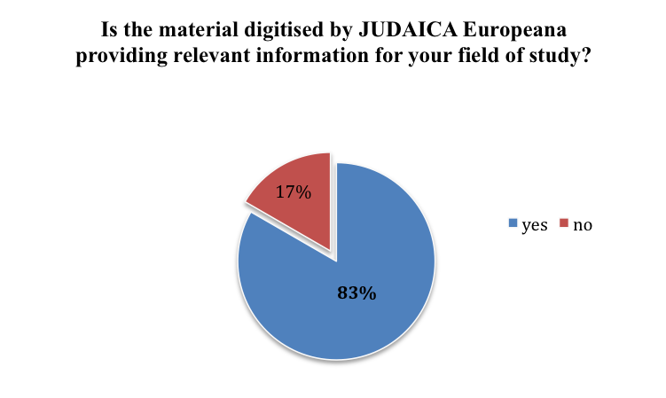
Comments:
- Very well. Especially oral history
- No – my field of study does not concentrate on Jews in cities
- Yes and will do so even more once the Jewish Museum London items are posted online
- Very relevant and very interesting. Looking forward to analysing the sources
- Yes, I study various areas of Jewish history so for research, for essays, etc accessing online collections & historical (personal) interviews etc will be helpful
- Once the Yiddish texts are translated and incorporated the material will be relevant
- Yes – doing MA in Holocaust Studies
- Yes, giving information about Jews in Britain – research needed for our studies
- Yes, looking at Jewish social/cultural lives in England. It’s a very useful tool to know about
- Yes – material was relevant to the study of Jews in English-speaking lands
- Not at the moment
- Possibly
- Very relevant for my own work on “Modern Jewish Culture and the big City” and for my research on German-Jewish emigration in the 1930s; also very relevant for the work of colleagues in the Parkes Institute, notably Tony Kushner (migration, transmigration), Claire leFoll (Yiddish language and theatre), Hannah Ewence (Anglo-Jewish community and suburbanization), James Jordan (Jews in British Film and Television), and others.
- As a researcher, the digital collections have helped with my research, by making many of the items at the Budapest Jewish archives and elsewhere readily available. As a teacher, I have already found the synagogue postcards and other images particularly useful in providing visual illustrations of the topics we are discussing in class.
- The topic of my research is how museum pedagogy can make contacts with different cultures. In this topic I will particularly focus more on the digital museum pedagogy because all the digital collections in Judaica Europeana can be used as a teacher’s tool.
- The digitization of collections encourages other collections to do so. It will also help the future cooperation between institutions all over Europe, since Europeana – in a way – works as a virtual list of fonds [collections].
- Connected to my historical work, I often come across all sorts of the history of European religions.
- The material on the website of the Hungarian Jewish Archive is amazing and very helpful in many aspect of research on Jewish history – it makes research significantly faster and easier for scholars who would use the archive otherwise too, and makes the materials accessible for people who would not even think of using it.
- I'm interested in the present tendencies of aggregation of cultural artefacts and sources using digital technologies, in particular by putting to surface and highlighting objects or sources, making them cultural heritage by describing and collecting them. I'm also interested in such applications for minorities and complex cultures, geographically and diacronically distributed, like Jewish one.
- Yes - I found very interesting the page with the list of Virtual exhibitions – especially Stella di Davide e Tricolore
- The material will be very helpful as far as my future studies, since the variety of its fields is vast. The digitised subjects shall help me produce more detailed essays.
- Yes –I will use the photos and information of Judaica Europeana objects mainly of Southern European Jewish museums for my future research
- Yes – I will be able to search easily objects I am looking for to study or see
- Not so much. Concerns more life before the war, whereas I am a Holocaust and post-war historian
- The material is an invaluable resource for research in Jewish studies. Rapid, easy access and the chance to discover things whose existence I was unaware of
- It will decisively contribute to my research about the Holocaust as well as my interest in cultural studies – easy to spot what you need
- It is a very accessible and rich source of the archival material, which I will use for the further research on the history and culture of Polish Jews. I am especially interested in the Breslau Jewish community archive digitalized by the Jewish Historical Institute in Warsaw. I find this extensive material well organized and easy to navigate. I appreciate the fact that I can use these files during my work at home – during the time when the archive is closed.
- I organise teacher-training courses as well as other educational projects for teachers as well as for students. I will advise them to use materials included in Judaica Europeana. I enjoy the variety of kinds of materials (images, texts, audio files) and virtual exhibitions
- Yes – I am specialist in Yiddish. Lots of material
- Yes – I am specialist in Hebrew manuscripts
- Yes - Judaica Europeana will facilitate access to Jewish cultural heritage in Poland and outside Poland. A lot of very important collections are not easy to access in “traditional” way because of bad condition, conservation regulations or simply the costs of travelling.
- My research, being involved in history, in particular the study of the conflicts that occurred between Jewish and Christians, I think Judaica Europeana is an extraordinary source of information.

Please comment on any information (text/illustrations/pictures etc) concerning Jewish urban life, Jewish expressions in the European urban space or Jews as urban celebrities you would like to see digitized that are currently unavailable:
- The Jewish street from Whitechapel in the post war period
- N/A
- N/A
- N/A
- N/A
- N/A
- N/A
- N/A
- N/A
- N/A
- N/A
- Difficult to say without seeing a wider range
- Hard to say – I am more afraid that there are smaller collections especially in Eastern Europe, but also in Spain and Portugal, which are not (yet) part of the project
- I would like to see more historical images, especially related to folk dress and folk customs of various Jewish communities.
- I do not know with certainty at this stage what might be missing from the Judaica Europeana collections. However I do believe that the work of Judaica Europeana is ongoing and anything new in this topic could serve well those collections.
- It would be good to have anything and everything online. All the uploaded objects show us little pieces from our shared history in Europe.
- No, there are not.
- Manuscripts, books, illustrated manuscripts/books, letters, pinkasim digitalized.
- I would be interested in finding also materials about organised Jewish paths inside cities, where existing, buildings, synagogues
- I don’t know
- No. Everything I would like to see is already online.
- Synagogues in Southern Europe, ritual baths, community buildings, Jewish homes
- N/A
- Archive of the Jewish Community of Athens
- N/A
- N/A
- I would like to see more art collections digitalized – not only postcards, but also paintings and graphics.
- N/A
- More Eastern, modern Yiddish Text
- N/A
- Collection of Jewish Museum in Vienna as well as other Austrian collections concerning Jewish heritage ie. archives.
- In general some images produced by Christians against the Jewish are not considered as sources for [documenting] Jewish life, even if “anti-Jewish painting” is indirectly a relevant source of information.

Question 2
Is this digital content a useful resource for your teaching?
The answers evidence that the electronic material is a very valuable resource for those who do teach classes (professors, associated professors etc.). Researchers or university students obviously did not reply to the question. Again the only negative reply comes from subject specialists whose field of study is not yet covered by any digitized item.

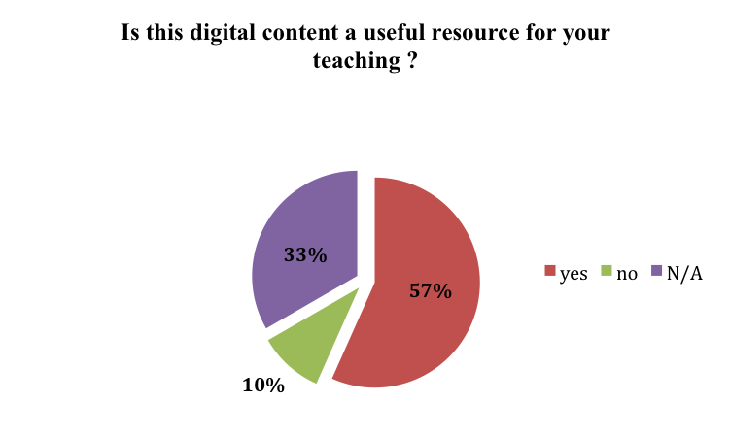

Comments:

- Yes
- No – limiting the topic of the collection to cities can be hardly useful for my research
- Yes
- Yes
- N/A
- N/A
- N/A
- N/A
- N/A
- N/A
- Yes
- Yes
- Yes very useful both for my 2nd year course “Modern Jewish Culture and the big City” and my 3rd year Special Subject “Street Life in the Modern Metropolis”
- Yes. So far I have used them mostly in my teaching, but as the collections grow, I will be able to use them for research, too.
- I enjoy how different European institutes are bringing together one common European Jewish heritage and all that is available online from everywhere for everybody. Watching the different collections can shows you how much a culture can contain.
- For now, we acknowledge the collections on Europeana. By knowing the material that other museums and archives have, we can extend our hypothetical collection as well, and think of the virtual exhibitions as part of a big European heritage.
- Yes. The collection of postcards of Hungarian Jewish Archives.
- Yes
- Yes. A large-scale selection of sources, extremely various for typology, provenance, coverage, but strictly connected among each other and with other millions of materials included in Europeana, the European “collection of collections”
- I would like to contribute to the exhibit with my family history
- Of course! I enjoy that everything is categorised within fields, such as “photographs”, “books”, “postcards” etc, is the most important thing when you are searching for specific subjects
- N/A
- N/A
- N/A
- Too early to say
- It is exactly the kind of information I need with easy navigating tools and of good digital quality. I have been waiting for the files of the Jewish Historical Institute for a long time and I hope there will be more and more of these archival material accessible.
- N/A
- N/A
- Yes. It takes students to the originals and then teach with digitized images
- Yes

Question 3
For what kind of purpose will you use it?
Academic users are likely to exploit the Judaica Europeana collection in their teaching, learning and research. The types of uses envisaged are individual research projects, especially genealogic research as well as pedagogical work with children, young adults and with students in master classes and University courses. Others consider Judaica Europeana a “brilliant case study” on its own and a significant example of a collective digitisation effort to be used in classes on digital humanities.

Comments:
- Jewish culture in Britain
- N/A
- As a research tool for Masters students (Jewish History and Culture MA), and as a tool to find engaging visual material for discussion and analysis in my second year module ‘The making of Englishness’. Material on the East End Jewish immigrant community will be especially relevant.
- N/A
- N/A
- N/A
- N/A
- N/A
- N/A
- N/A
- Paper research
- Teaching and research
- Very useful both for my 2nd year course “Modern Jewish Culture and the big City” and my 3rd year Special Subject “Street Life in the Modern Metropolis”
- So far I have used them mostly in my teaching, but as the collections grow, I will be able to use them for research, too.
- I will use the virtual exhibition of the Jewish postcards for my research about how museum pedagogy can make contact with different cultures. The exhibition can teach you a lot about the Jewish culture, traditions, holidays etc. So I can watch the collection from a teacher’s perspective. I will also use the exhibition in my museum pedagogical work with children and young adults.
- For now, we acknowledge the collections on Europeana. By knowing the material that other museums and archives have, we can extend our hypothetical collection as well, and think of the virtual exhibitions as part of a big European heritage.
- The material in Judaica Europeana digital collections is going to be very useful in my historical research.
- In fact, I have already used the postcard collection in a Yiddish language course of mine, where one of the tasks students had to do for a grade was to choose a few postcards with Yiddish poems on them and translate the Yiddish into Hungarian. The databases are extremely helpful for checking historical data, family names, family relations, cultural history, for genealogy research, etc.
- I approached Judaica Europeana because it's extremely significant as a brilliant case study in my lessons about digital applications for cultural heritage and in my research about users usage of new forms of aggregation of cultural information
- N/A
- The variety of documents (Jewish, German etc..) will help me complete more detailed projects
- Compare the objects with our own collections
- Probably as additional image material in my essays – search different collections
- Not really. There is already material from other sources
- Too early to say
- Not in the next future but I shall definitely find manuscripts photographs useful for future presentations
- It is useful both for my work in the museum, but also for me as a scholar who writes articles, participates in conferences and teaching students.
- I am specialist in Holocaust literature. If only I find any appropriate material to be used (to illustrate my classes for example) I will use it definitely
- My courses Yiddish literature and introduction to historic sources
- Comparing types of manuscripts with images and texts from printed books
- Research for the permanent exhibition and temporary exhibitions program as well in the Educational programs.
- I have used some digitalised material useful to my research during my lessons at University as a collection of both images and texts.

Question 4
Do you think that this digital material represents a resource that can be included in virtual learning environments such as on-line courses or used in whatever online production you may manage (website, blog, Facebook or others…)?

The notorious dichotomy “Apocalitici e Integrati” introduced in 1964 by Umberto Eco distinguishes between conservatives who warn against the negative effects of mass media and less censorious progressists. A similar thing happens here. We have academic users who absolutely advocate for on-line courses and already have in mind their course title and learning platform and others, more cautious researchers, who fear mis-usage of the digital material and want the on-line application strictly limited to the academic community. Finally there is a third group and a minority who are still or not yet “concerned” with on-line teaching.

Comments:
- Has to be done! And co-operate with other museums in Europe (Jewish museums)
- It might be useful for online productions but hardly for any online courses that require more relevant materials
- Yes absolutely
- N/A
- N/A
- N/A
- N/A
- N/A
- N/A
- N/A
- Yes – online courses
- Yes – most likely website links
- We are planning an e-learning element of our MA Jewish History and Culture where such material will be most useful and relevant
- Yes, certainly. Perhaps the Judaica Europeana digital collections could even design short presentations using the materials. I don’t know how these would be used on Facebook, but they could certainly be linked to on websites of various Jewish Studies programs and museums. We will add the link to our website at CEU.
- I think the collections in Judaica Europeana are giving a very good opportunity for online courses and e-learning. It would be really good to have online courses what interested people could take partly on their own. I can imagine courses for children where they get to know more about the Jewish traditions and culture, and also online courses for teachers about how to use the collection as a tool of their pedagogical work.
- Definitely. Since Europeana gathers so many collections, and have a surface that’s easy to handle. Also transparent, it seems convenient to use the uploaded material in any project.
- I am not concerned in it.
- Definitely: history and cultural courses can be based on material that is thus easily accessible from anywhere; pictures, photos, postcards can serve as illustrations for course material, for events and advertisements, etc.
- It could be possible to include selections of Judaica Europeana materials inside our elearning platform OLAT, as well as in our Facebook university environment, by applying “share” functions
- I don’t understand why it is not linked to Google. Nobody knows about it. If I digit in Google “ebrei italiani” or “stella di Davide” there are many other results but not Judaica
- Of couse! Categories such as artifacts of religious, personal or domestic interest, photographs, textiles, costumes and in general all the categories can be easily used for all the above mentioned examples.
- I don’t know and will not manage any on-line production
- In virtual learning environments yes. In social networks I don’t think so
- Could help as a source for material, but the idea of putting it on Facebook et al. is not a very good one.
- Potentially yes, but I have not yet worked out how.
- Only under specific regulations such as restrictions in possible bad use of the material – facebook. Twitter or even blogs should not be an option.
- Yes, I am convinced that Judaica Europeana should be widely accessible, also via the popular portals like Facebook and blogs. It will make the work of teachers as well as students easier. This is also how the knowledge in the modern knowledge should work – be promoted on any level.
- I am not very familiar with virtual learning.
- Yes we shall develop e-learning material
- Yes especially for online publications
- Virtual exhibitions
- I haven’t used any on line virtual learning/teaching environment so far, so I cannot answer to this.

Final comments and suggestions
- I would have preferred if the Judaica Europeana collections could be accessed also independently from Europeana’s whole collection, in order to put better in evidence the selection criteria and create virtual collections just choosing Jewish cultural materials
- Well done! The digitisation that Europeana has produced is exceptional and it will help everyone that needs information of such an interest.

3.2 Key Findings teachers
One of the chief aims of Judaica Europeana is to encourage the education community in further and higher education to use and re-use the digitized resource in classroom.
This is why the user evaluation was extended to teachers.
The Jewish Museum in Athens conducted a workshop. The other partners contacted teachers individually and invited them to evaluate the digital resources remotely from their computers.

Involved teachers
- Anna Janina Kloza, deputy director of the school, educator, organisation of educational projects, King Zygmunt August High School No. 6, Białystok, PL
- Robert Szuchta, expert at the Polish Ministry of Education, PL
- Plawner, teacher, the I.E. Lichtigfeld School at the Philanthropin, Frankfurt, D
- Schoenfeld, teacher, the I.E. Lichtigfeld School at the Philanthropin, Frankfurt, D
- Dold, leader of secondary school, the I.E. Lichtigfeld School at the Philanthropin, Frankfurt, D
- S. Hey, teacher, the I.E. Lichtigfeld School at the Philanthropin, Frankfurt, D
- Anonymous, teacher modern history, Scuola Secondaria di Secondo Grado Renzo Levi, IT
- Katalin Gyárfás, teacher social studies focusing on judaism, Lauder Javne Jewish Community School Budapest and Zachor Foundation, HU
- Balázs Gábor, teacher history, literature, Jewish studies, communication, English, geography, American Endowment School, HU

Question 1
How will the material in Judaica Europeana digital collections affect your future research/work?
Is the material digitised by Judaica Europeana providing relevant information for your field of study?
All teachers responded positively to this question. Responses unequivocally show that the digital resources provided by Judaica Europeana do support teaching and learning. They are considered “spectacular tools” and educationally sound contextual information and important learning objects that can help to engage, motivate and cultivates cross cultural understandings and the value of diversity. It allows pupils to make meaningful connections between life today and the past starting from primary sources.

Comments:
- Judaica Europeana gives better access materials concerning Jewish heritage in different European countries. It is important to show students how Jews were/are living in other cultural areas.
- I will advise my colleagues to review these materials. I am interested mostly in the source materials. I hope to find them in the future.
- Yes it is useful to see the original material in a digital form
- Yes it gives illustrations of Jewish Religious life
- Yes it is very useful
- Yes it provides partly relevant information
- I will use more Internet resources in my lessons, which I never did before
- The digitized version of the contemporary (1859) seating chart of the Dohány Synagogue (Budapest) is a spectacular tool in the hands of school teachers and other educators making efforts to introduce the social composition of the early years of the so-called Jewish Golden Age in Hungary. The chart is also telling evidence about the efficiency of leadership the mid-century Jewish Community of Pest city. Looking at the charts the students will understand in the most expeditious way the dynamics of the community on and around the September 1859 opening ceremony of Europe’s largest Synagogue.
- It will help to prepare curriculum to teach about minority cultures (especially Jewish culture, religion and history) in Hungary. The postcards will help the students to gain a profound knowledge of their cultural inheritance. The material will enable students to do independent research.

Please comment on any information (text/illustrations/pictures etc) concerning Jewish urban life, Jewish expressions in the European urban space or Jews as urban celebrities you would like to see digitized that are currently unavailable:
The emphasis concerning requested and yet not available digital resources is clearly on “modern Jewish life”. Teachers ask for illustrations and photos that bring the Jewish cultural elements to new generations in ways both inspiring and relevant to contemporary life. Presenting Jewish music is a fundamental element for cultural literacy.

- Jewish music
- There should be more descriptions of the objects in national languages. The same concern virtual exhibitions
- It would be interesting to see more current pictures,
- Interesting illustrations, more photos of daily life would be useful
- Modern Jewish life, Jewish culture, religion, communities
- Modern Jewish life all over the world would be helpful in terms of e.g. comparison
- No
- I find the collection of resources currently available online completely satisfactory. And I am happy incorporating them in my educational activities.
- The heritage of the manuscripts of the great Hungarian rabbis. (Bacher, Blau, Kohn, Kaufmann etc.)

Question 2
Is this digital content a useful resource for your teaching?
The respondents value the electronic material because it enlarges and enriches their repertoire for presenting content.

Comments:
- Yes- Easy access; possibility to download materials for both: students and teachers to prepare presentations
- Yes - Good access for everybody that is interested in downloading materials or using them on-line. I think it will be helpful for students
- It absolutely can be
- Yes
- Yes
- Yes if used wisely and correctly
- Yes with the accessibility of texts and exhibitions
- Yes. I enjoy most the clarity of the images, and the way the century German language entries make the students to understand the composition of a socially upward climbing community.
- Yes. This material reveals an unknown aspect of Hungarian Jewish past in an enjoyable form.

Question 3
How are you going to use material in Judaica Europeana digital collections in your teachings?

Teachers clearly consider the resources provided by Judaica Europeana appropriate for teaching in the “digital age”. We could sum up their comments on the added value of the digitized material with: meaningful, visual and authentic.

Comments:
- I run a number of projects on different aspects of Jewish history and culture. It will give me an opportunity to use new, mostly unknown materials
- N/A
- As an emphasis for already given information – as an original source
- Preparing sessions on Jewish holidays, costumes that have remained, different ethnic backgrounds
- Teaching Jewish life, guiding tours to the Jewish museum
- For additional information on the topic we deal with
- Starting from each one of the collections presented in Judaica Europeana is possible to develop a discourse on Jewish life in Europe in a visual way, that should be more attractive for the students
- I will use it in my teaching projects to demonstrate a social situation and simultaneously the process of assimilation, which was a major trend ten years after the end of the 1848-1849 uprising and freedom fight, and a year before the birth of Theodor Herzl.
- It will help the students to have a personal approach to the past of their community, and it will enable them to connect places, persons, events of the past to the reality of their present.

Question 4
Do you think that this digital material represents a resource that can be included in virtual learning environments such as on-line courses or used in whatever online production you may manage (website, blog, Facebook or others…)?

The teachers do not fear new learning environments. They seem to approach this new teaching boundaries in a way that will benefit the student's learning.

Comments:
- Yes. Although it is still not very popular in Poland.
- N/A
- Facebook would be less suitable but for purpose of advanced studies rather helpful
- Yes for preparing presentations for the pupils for the class
- Part of them yes – others are too abstract
- I believe a part can be used, but not all are entirely helpful
- I don’t manage any
- Yes. I definitely believe that the material in Judaica Europeana digital collection can be included in virtual learning environment. E.g. our students can use them as illustrations preparing their papers concerning subjects in the realm of Judaic Studies.
- N/A

3.3 Key Findings Academic Advisory Group
The Academic Advisory Group was involved in a formative evaluation of the main virtual exhibitions organised in co-operation with Europeana. The involve members were:
- Dr Francois Guesnet, Department of Hebrew and Jewish Studies, University College London, UK
- Dr Gadi Luzatto Voghera, Department of Historical Studies, Università Ca' Foscari di Venezia and Centre for Italian and European Studies, Boston University Padova Program, also Director of the Jewish Library and Archives in Venice, Italy
- Dr Laura Quercioli-Mincer, Department of Slavic and Central-Eastern European Studies, University of Rome, Italy
- Professor Antony Polonsky, Near Eastern and Judaic Studies, Brandeis University, US
- Dr Gerben Zaagsma, Yiddish studies, University College London, UK

Virtual exhibition 1: From Dada to Surrealism: Jewish Avant-Garde Artists from Romania, 1910–1938

This online exhibition is based on the exhibition held at the Jewish Historical Museum, Amsterdam from June to October 2011. It is hosted by Europeana and can be viewed in English, Dutch, French, German and Spanish. The exhibition confirms the importance of Jewish Romanian artists in European avant-garde art and sheds light on the relationship between Jewish identity and radical modernity.

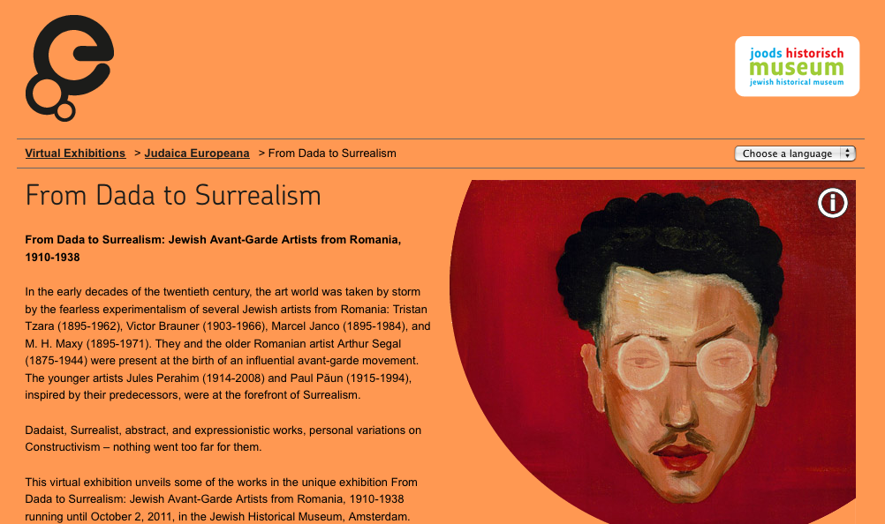
Fig. Screenshot “From Dada to Surrealism”

Question 1
What did you like most about this exhibition?
AAG members report about a very pleasant moment of discovery. Both exhibitions were built around such specific topics that even experts in the field were fascinated and surprised to find new perspectives, seemingly unexpected cross-fertilisations and important “connections between a seemingly peripheral Jewish community and Western European Avant-garde art (brilliant). AAG members were comfortable with the informative text and the quality of videos and pictures.

Comments
- The well-balanced presentation of the idea and the (Romanian Jewish) protagonists of Dada, as well as the surprising connections between a seemingly peripheral Jewish community and Western European avant-garde art. Brilliant.
- The idea of spreading knowledge about the relationship between Jewish young generation of artists in Europe and the Dada movement
- I was fascinated by the fact that surrealism had such an impact in a country like Romania
- I did not know probably any of those artists and I learned a few new very interesting topics. All pictures are very nice. The video at the beginning is attractive
- Well written, concise but informative texts.

Question 2
What did you like less about this exhibition?
AAG member response to the exhibit was almost unanimously positive (Prof. Antony Polonsky even asks the exhibition to expand). Somebody was concerned that the exhibition structure put too much spotlight on Romania and hence “tends to obscure” the fact that this complex artistic and literary movement embraced several countries and influenced artists in many cities. One member suggests more interactive experience.

Comments
- The introduction seems very short, and overall, the exhibit is small. It is not entirely clear why other centers of Dada, obviously above all Paris and Berlin, are not discussed. Just because there are no Romanian Jews? The structure covers important aspects, but would need to be better explained.
- N/A
- The only criticism I have is that I would have liked the exhibition to be even larger
- Void
- The focus on individual stories tends to obscure insight into the movement as a whole. The setup is rather classic: some text with an image, as if it is an online version of a book and not really interactive.

Question 3
What topics did you miss in the exhibition?
Some AAG members ask for more background information to better complete the picture on both the Dada movement and the situation of Jews in Romania.

Comments
- Other centres of Dada
- N/A
- I would have liked more background on Jews in Romania
- I don’t know the theme so well to suggest new topics. It seems ok to me
- A bit more context on Dada in general.

Question 4
What improvements would you suggest?
One member wishes to see more highly valued film material and suggests integrating some musical elements. Biography of artists could be concentrated in one place only.

Comments
- The exhibit – at least in my computer – is very slow. If I didn’t have to, probably I would not have to patience to browse it. Like in the other exhibit., I miss here some music. The video at the beginning is great, It would be good to have some more. I didn’t find very useful the repetition r. biographies of artist in the 1930s section

Rating of exhibition parts
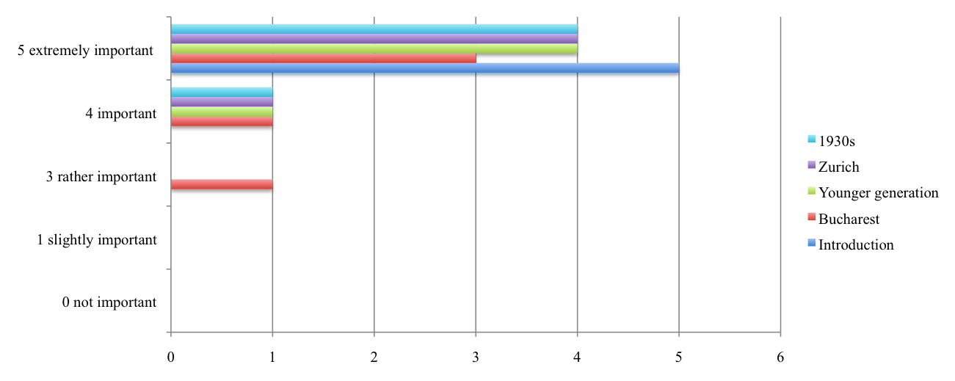

Virtual exhibition 2: Yiddish Theatre in London

The exhibition was produced by the Jewish Museum London and is based on JML’s collection. It is hosted by Europeana and can be viewed in English, French, German, Dutch and Spanish. The exhibition explores the theatre form brought by Jewish immigrants from Eastern Europe in the late 19th century, which resulted in the heyday of Yiddish theatres in London in the early 20th century.

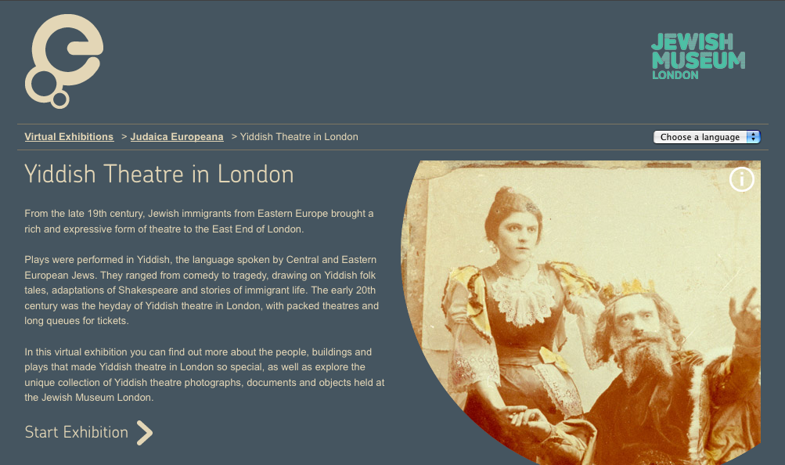
Fig. Screenshot “Yiddish Theatre in London”

Question 1
What did you like most about this exhibition?
AAG members appreciate the sophisticated, clear design and the quality of visuals. Again the exceptional topic is a well-received surprise factor.

Comments
- The very sophisticated selection and first class presentation of visuals!
- I learned a lot about a world I ignored almost completely.
- I knew about the Yiddish theatre in New York, but knew much less about that in London. As a result I learned a lot from the exhibition.
- The exhibition is simple, clear and generally well done. Texts are short and easy to read.
- Concise overview with good selection of images.

Question 2
What did you like less about this exhibition?
According to the expert judgement, some descriptive parts are considered oversimplified and the undoubtedly elegant layout is perceived as too “cold” to reproduce the atmosphere typical for Yiddish theatre.

Comments
- The simplistic presentation of history. The Eastern European background is too short (e.g. obviously Yiddish theatre continued to thrive both in Tsarist Russia as well as in other parts of continental Europe) and follows an outdated master-narrative. The presentation reads like an advert to one of the theatres presented ("star-studded" etc.). An Internet exhibition can be short without “dumbing down the viewer”. One caption is plain wrong: there are no queues in front of the theatre; I assume these are members of the ensemble and theatre team.
- I would have appreciated more details about the plays.
- If there could have been some material from actual performances this would have been very good.
- It does not give the warmth and the pleasant confusion of Yiddish theatres.
- Texts are very short and the exhibition thus becomes quite superficial and a bit too generalising. Also, the setup is rather classic: some text with an image, as if it is an online version of a book and not really interactive.

Question 3
What topics did you miss in the exhibition?
The information on actors could have been more exhaustive and objects connected with music that shares the distinctive pasts.

Comments
- As part of the part on 'closing the curtain: who were actors or directors who successfully moved into non-Yiddish segments of the British (American?) entertainment industry.
- Void
- I would have liked some recordings of the music used in performances.
- Void
- Difficult to say in such a short panorama. Maybe something more about the life of single actors?
- I did not miss so much as would wish for more information.

Question 4
What improvements would you suggest?
Combine the artefacts with music and be more colourful.

Comments
- Much more music – with the possibility of hearing and seeing at the same time. Some short videos. And colours, colours, colours!

Rating of exhibition parts

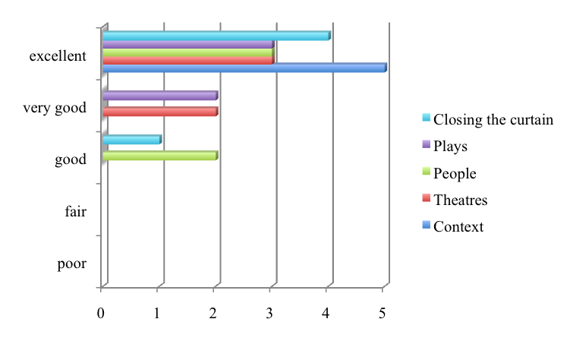

Conclusions
Overall AAG members enjoyed the two exhibitions and were generally very satisfied with their aesthetic appeal. The nature of the displayed material is of academic and personal interest.
Generally visitors of virtual exhibitions indicate that images should be plentiful and the focus of the exhibition, with texts playing a supporting role. This sort of “golden rule “is not true in case of content experts for whom text is never secondary.
Critical comments coming from the Accademic Advisory Group (AAG) make it clear how difficult and challenging it is for curators to extend their expertise into a digital environment and encourage visitors to interpret objects online. As already underlined by Klaus Mueller (2002) l “Today most museums use the Web to fulfil their traditional roles—to document, educate, and preserve—by transferring existing information and reproducing physical objects in an electronic form. A radically different approach is to use Web sites to present art and exhibitions that exist only in electronic form, thus turning the Web into a medium of original experience.”
We must consider that for JUDAICA partners it was their very first virtual exhibition. Any online exhibit resides in a medium that functions according to its own set of rules. This set of rules is known by media designers but rarely by museum or library staff who still have to learn how to augment and customise its new on-line data repositories.
It is all too understandable that the first implementation step is probably an on-line version of a book as is the predilection for visible elements (images and text) instead of audio file and a successful combination of both to create a variety of other compositions. However, ambitious expectations are inherent to the development of online exhibitions. As with on-line training courses the investment is often underestimated and most museums do not have the 20 million dollars the Guggenheim spent on its Web site.

3.4 Those who found us

We would like to dedicate the conclusive parts of this report to those users who FOUND US commenting on our work spontaneously.

Subject: Yiddish theater exhibition

A wounderful site and a very rich exhibit. However, I was surprised by the fact that there is no mention of A. N. Stencl nor Dora Dymant among the actors shown or spoken about…

Yvette Métral
Entertaining the Nation: Stars of Music, Stage and Screen

Subject: British Jewish History in 50 Objects online exhibition

To whom it may concern,
Thank you for making this exhibition on line. I cannot easily get to the Jewish Museum so it was such a lovely surprise to receive and access your virtual exhibition - brilliant!

Every good wish
Pauline Jeffree

Subject: British Jewish History in 50 Objects online exhibition

What did you like most about our exhibition?
I did not have to leave home and that is fantastic for people with mobility problems - it keeps us in touch with what is going on. Well done !
What did you like least about our exhibition?
I loved it all
What other subjects would you like to see in an online exhibition?
Info on where people arrived Tilbury or Hull. What was the housing like? Photographs.

Subject: British Jewish History in 50 Objects online exhibition

What did you like most about our exhibition?
The range and scope of the objects: some very humble and moving
What did you like least about our exhibition?
Nothing

4. Multilingual, cross-border use of the Judaica content
The Judaica Europeana project partners and associate partners cover a large number of countries reflecting the multilingual and multicultural aspects of Europe.. The full and associate partners provided content on their main language as well as content belonging to other geographic areas.
According to its original objectives, Judaica Europeana was expected to provide content in eleven languages: English, French, German, Greek, Hebrew, Hungarian, Italian, Judeo-Spanish, Latin, Polish and Yiddish.
Following the latest version of the Judaica Europeana ingestion plan, two more languages have been added, namely Dutch and Spanish, so covering all the most spoken European languages.
Some partners have indicated availability of content in other additional languages.

Currently, due to the non-homogeneous harvesting of content within the Europeana system, some languages are more represented than others. The multilingual analysis tools provided by the Europeana server, are not entirely accurate. They automatically assume that, for example, all content from a Polish provider is in the Polish language. Content in Hebrew from the German and other providers is also not shown. However, the current breakdown per country provides valuable information. It is as follows:

Country Amount
Spain 142
Hungary 2.002
Yiddish 3.418
Italian 6.094
Greece 9.447
Netherlands 13.750
UK 14.836
France 26.322
Germany 74.399
Poland 219.848
Hebrew content 44.460
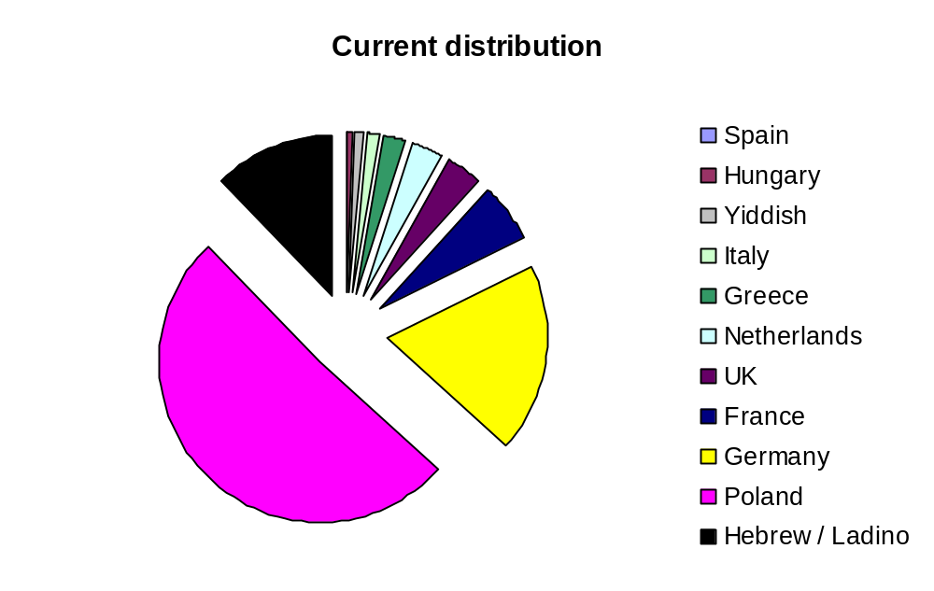

The expected final distribution of languages, based on the final version of the implementation plan, is shown by this second table:
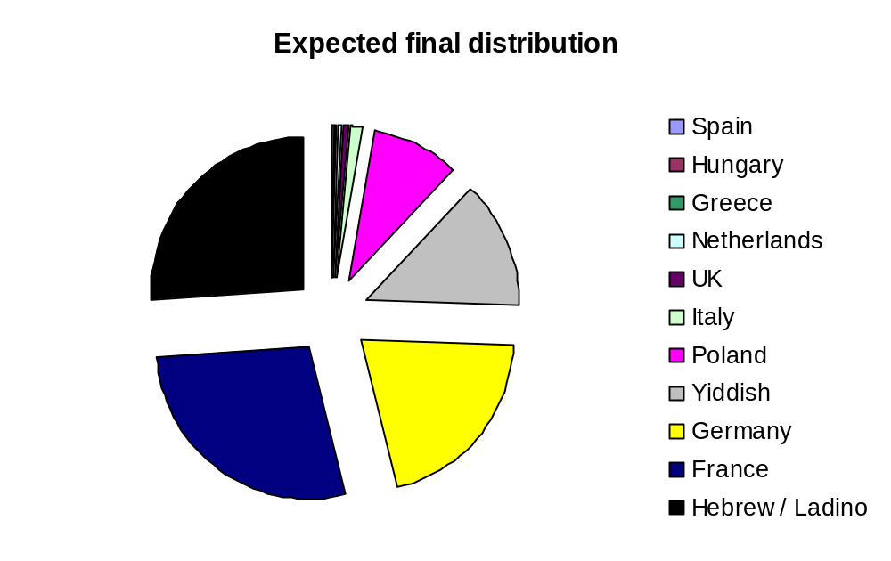

4.1 Web statistics of special events: online exhibitions
A particular attention has been given to analyse the web traffic generated by special events in the project’s lifetime, such as the organisation of online exhibitions.

In particular our attention focused on two exhibitions, namely:
- From Dada to Surrealism
- Yiddish Theatre in London

These two exhibitions can be accessed through the Judaica Home page, Europeana and Partners‟ websites. Since they were the first two exhibitions organised by the project - other virtual exhibits have been added during the project lifetime – the analysis of the users feedback provide us with more relevant information.

From Dada to Surrealism: Jewish Avant-Garde Artists from Romania, 1910–1938 presented online the highlights of a physical exhibition shown at the Jewish Historical Museum, a Judaica Europeana partner in Amsterdam: http://exhibitions.europeana.eu/exhibits/show/dada-to-surrealism-en

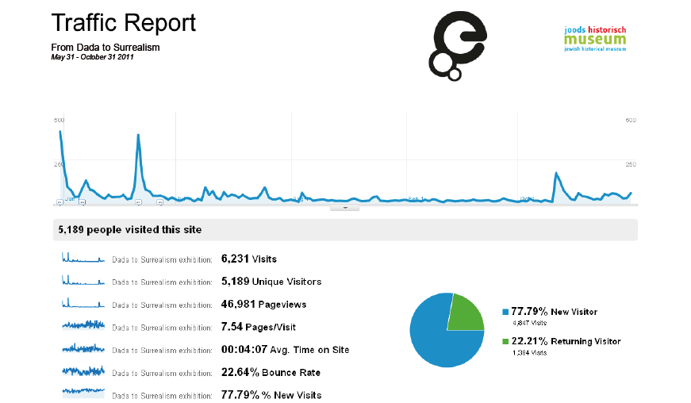
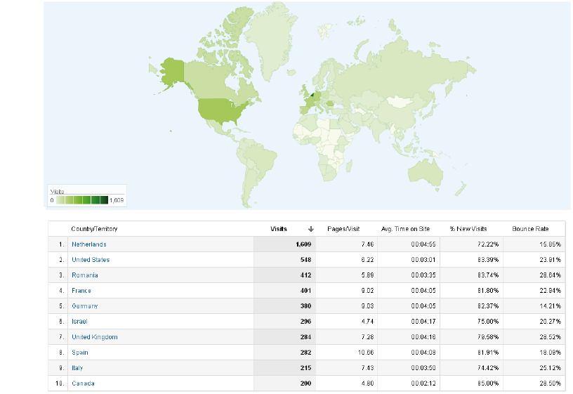

It is important to underline that the web traffic jointly generated by the europeana.eu and the judaica-europeana.eu, i.e. the people visiting the exhibition arriving from a link present in the Europeana and Judaica Europeana web sites, reached the 32,19% of the total number of visits.

Yiddish Theatre in London was a virtual exhibition hosted on Europeana showing a unique collection of photographs, documents and objects held at the Jewish Museum London.: http://exhibitions.europeana.eu/exhibits/show/yiddish-theatre-en

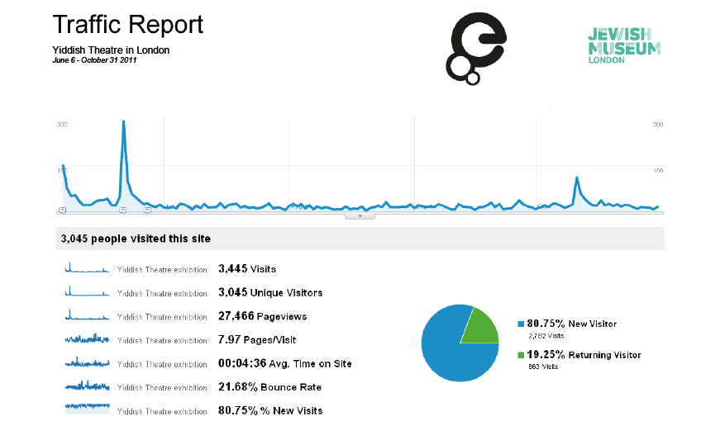
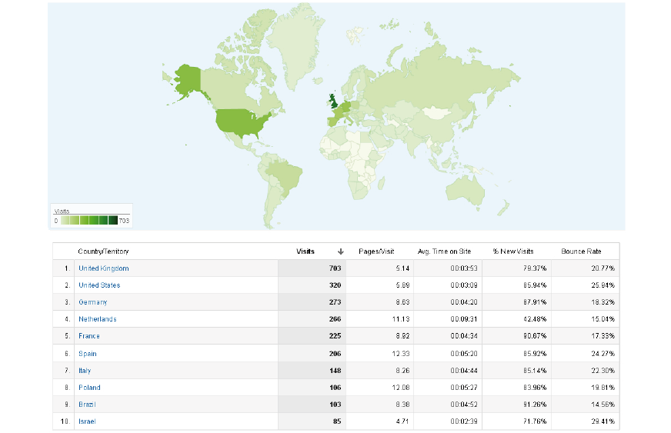

For this second event, the web traffic jointly generated by the europeana.eu and the judaica-europeana.eu, i.e. the people visiting the exhibition arriving from a link present in the Europeana and Judaica Europeana web sites, arrived to the 49,81% of the total number of visits.

4.2 Web statistics of the judaica-europeana.eu website
The project website represents one of the main tools for promoting and disseminating the activities of Judaica Europeana. The visitor’s statistics are monitored through Googleanalytics.
They present a high number of countries accessing the web site from all over the world
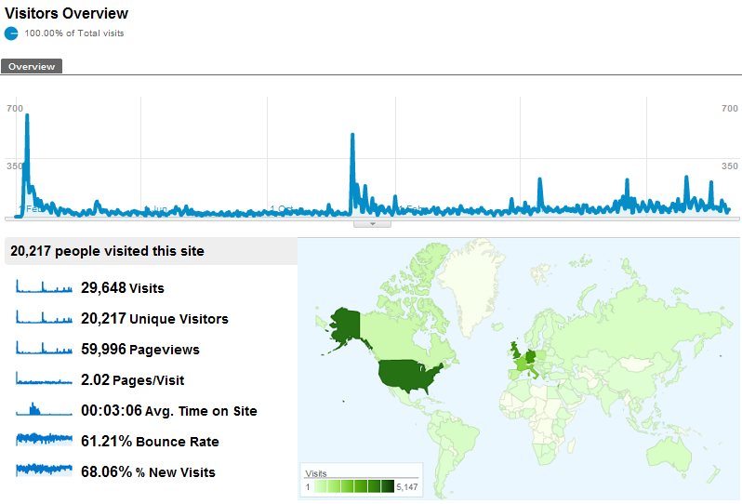

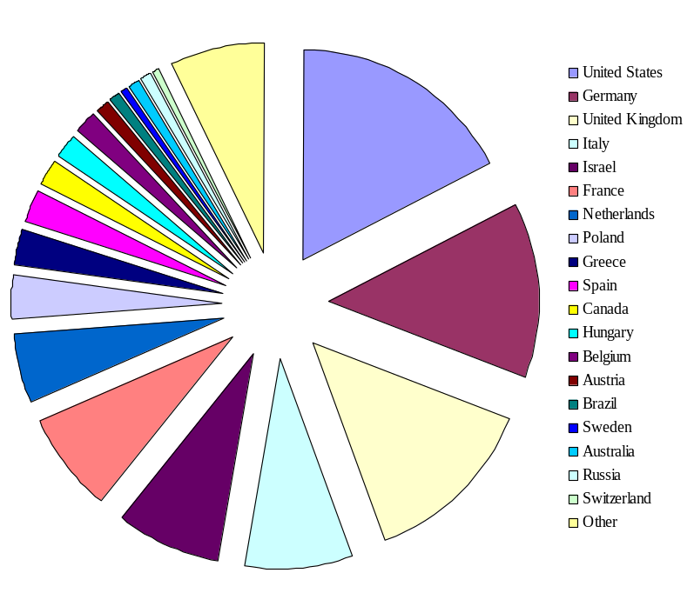
The wide geographic and linguistic spectrum of visitors to the Judaica Europeana website and virtual exhibitions indicates that the users came from a variety of different cultures.

Up to 19.12.2011, the web site received 29.648 visits from all over the world.
The leading countries in terms of visitors are the United States; Germany, the United Kingdom,
Italy, Israel, France, the
Netherlands and so on.

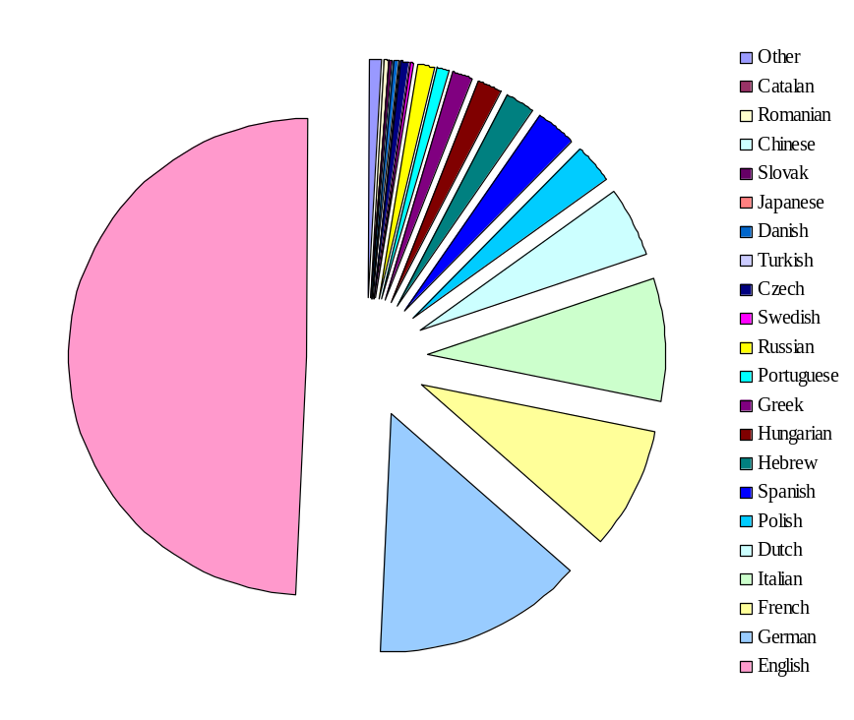
The languages used to access the site are presented in the following table. Almost 50% of the visitors used the English language. The following table presents the full distribution: the languages with less than 30 visits have been grouped under “Other”.

Annex I: Event Evaluation 2010
This questionnaire was used on the occastion of Judaica Europeana Digital Humanities Workshop 2010

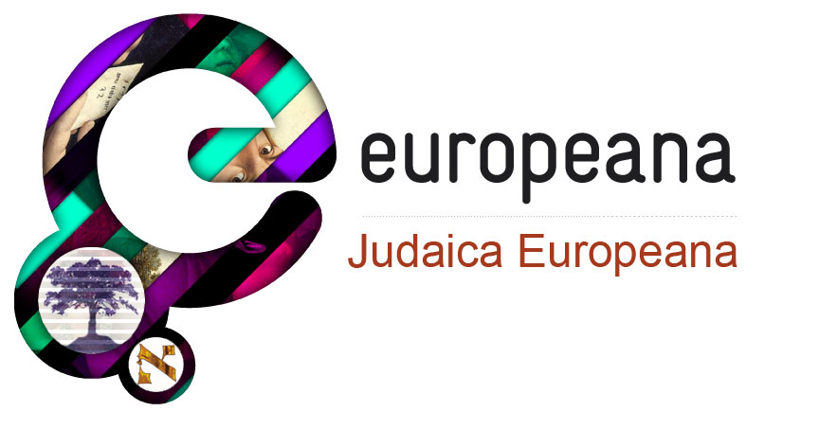

Event:
Location and Date:

Thank you for participating in this activity. Your feedback is important to us as it helps us improve what we do – we would appreciate if you could take a couple of minutes to evaluate today’s event.

How would you rate this event?
Content Poor  Average  Good  Very Good  Excellent 
Location Poor  Average  Good  Very Good  Excellent 
Speaker Poor  Average  Good  Very Good  Excellent 

In one sentence, please describe your thoughts on this activity with respect to its value for you.

What could have been covered more quickly, what needed more time, and what wasn’t covered?

Do you have any suggestions on how this activity could be improved?

Other feedback or comments:

Optional - Name:

Thank you for completing this evaluation
www.judaica-europeana.eu

Annex II: Event Evaluation 2011
This questionnaire was used in occastion of Judaica Europeana Digital Humanities Workshop 2011

Judaica Europeana

We are interested in your views on today’s event and on Judaica Europeana. Thank you for taking time to complete this form.

Name:

Organisation:

Email:

Main research/interest areas:

Would you like to sign up to the Judaica Europeana newsletter, to receive email updates on the project and the latest collections to be uploaded? Please tick to sign up

1. How would you rate the event overall?

Excellent Very Good Good Neutral Poor Very Poor

2. Please let us know if you are…

Taught postgraduate Academic researcher Personal researcher

PhD student Undergraduate Other (please state)

What is your field of study/work?

3. How will this event affect your future research/work?
4. Is the material digitised by Judaica Europeana providing relevant information for your field of study?
5. Are there any resources concerning Jewish life in Europe you would like to see online that are currently unavailable?
6. Are you going to use material in Judaica Europeana digital collections in your research, teaching or projects? If so, how?
7. Other comments/suggestions:
8. How did you find out about this event?
Friend/colleague website What’s On guide

University Other

This questionnaire was used in occastion of the AEJM Annual Conference 2011, Workshop B: Digitising collections and producing online exhibitions

Judaica Europeana

We are interested in your views on today’s event and on Judaica Europeana. Thank you for taking time to complete this form.

Question 1
How useful did you find this workshop?
Please give a score from 1(low) to 5 (high)
How will you use the information provided to carry out your own digitisation plans?
Question 2
Is this digital content on Europeana a useful resource for your museum (e.g. as an educational tool or for collections research etc.)? yes/no
Please explain
Question 3
Do you have collections already digitised concerning Jewish urban life, Jewish expressions in the European urban space or Jews as urban celebrities that you could contribute to the Judaica project?
Question 4
If ‘no? to the above question, do you have plans to digitise your collections now or in the near future?
Question 5
How useful was the information provided in the Virtual Exhibitions presentation?
Please give a score from 1 (low) to 5 (high).

If you have any other comments or suggestions for improvement, please add them below

Thank you for completing this evaluation
www.judaica-europeana.eu

Annex III: Evaluation Questionnaire for scholars/researchers/teachers
This questionnaire was used by the project partnes for collecting user feedback from the Judaica Europeana target users

Date:
Organisation Name:
Contact Name:

Please mark the target group(s) you are included in.
- Scholars, researchers, students in the area of Jewish studies
- Scholars, researchers, students in the area of history, urban studies, sociology, anthropology, literature.
- Staff at libraries and archives
- Staff at other cultural heritage institutions (museums, cultural centres)
- Other (please state)

Short background information
JUDAICA Europeana is one of a series of initiatives supported by the European Commission to establish EUROPEANA, the European digital library. JUDAICA aims to document Jewish presence in European cities and the contribution of Jews to European urban civilization. The project identified and digitised books, documents, sound recordings, photos, artworks, postcards, posters, etc… The digitisation carried out by the consortium enabled such objects to be included in Europeana.
We hope that this digital resource allows scholars, researchers, students to undertake and excel at their study and work.
Your feedback will allow us to gain a better picture of our users and their needs. Answer each question to the best of your ability.
This form is STRICTLY CONFIDENTIAL and will be used for reporting purposes only.

Question 1
Is the material digitised by JUDAICA Europeana providing relevant information for your field of study (please specify):

Please comment on any information (text/illustrations/pictures etc) concerning Jewish urban life, Jewish expressions in the European urban space or Jews as urban celebrities you would like to see digitized that are currently unavailable:
Question 2
Is this digital content a useful resource for your teaching? YES/NO
If no, please explain

Question 3 (
For what kind of educational purpose will you use it? (Please detail the subject matters)

Question 4
Do you think that this digital material represents a resource that can be included in virtual learning environments such as on-line courses or used in whatever online production you may manage (website, blog, Facebook or others…)? (please explain)

Question 4
Are you going to use material digitised by JUDAICA Europeana for local studies projects, intercultural and cultural diversity programs or similar initiatives?

If you have any other comments or suggestions for improvement, please add them below:

Thank you for completing this evaluation
www.judaica-europeana.eu

Annex IV: Evaluation Questionnaire for the Advisory Academic Group (AAG)
This questionnaire was used to collect comment from the Advisory Academic Group on the quality of virtual exhibitions organised with the support of Europeana.

Evaluation questionnaire
Please use this short questionnaire for commenting on the online exhibitions.
Virtual exhibitions are showcases for Judaica Europeana digital collections. They place images and documents in their historical and social contexts, and present Jewish history and culture to online visitors. The exhibitions can all be accessed from our home page http://www.judaica-europeana.eu/

YIDDISH THEATRE IN LONDON
The exhibition was produced by the Jewish Museum London and is based on JML’s collection. It is hosted by Europeana and can be viewed in English, French, German, Dutch and Spanish.
The exhibition explores the theatre form brought by Jewish immigrants from Eastern Europe in the late 19th century, which resulted in the heyday of Yiddish theatres in London in the early 20th century.

1) What did you like most about the exhibition?
2) What did you like less about the exhibition?
3) Of the topics we covered, please rank their relevance for your in order of 0, 1, 2, 3, 4, 5 where 5 = (extremely important) and 0 = (not important).
- Context
- Theatres
- People
- Plays
- Closing the curtain
4) What topics did you miss in the exhibition?
Thank you

Your name:
Date:
Please email the completed form to:

Evaluation questionnaire
Please use this short questionnaire for commenting on the online exhibitions.
Virtual exhibitions are showcases for Judaica Europeana digital collections. They place images and documents in their historical and social contexts, and present Jewish culture to online visitors. The exhibitions can all be accessed from our home page http://www.judaica-europeana.eu/

From Dada to Surrealism: Jewish Avant-Garde Artists from Romania, 1910–1938
This online exhibition is based on the exhibition held at the Jewish Historical Museum, Amsterdam from June to October 2011. It is hosted by Europeana and can be viewed in English, Dutch, French, German and Spanish. The exhibition confirms the importance of Jewish Romanian artists in European avant-garde art and sheds light on the relationship between Jewish identity and radical modernity.

1) What did you like most about this exhibition?
2) What did you like less about this exhibition?
3) Of the themes covered, please rank their relevance from 0, 1, 2, 3, 4, 5 where 5 = (extremely important) and 0 = (not important).
- Introduction
- Zurich
- Bucharest
- 1930s
- Younger generation
4) What topics did you miss in the exhibition?

Thank you

Your name:
Date:
Please email the completed form to:

OJ L 79, 24.3.2005, p. 1.
Saveed Choudhury, Benjamin Hobbs, Mark Lorie, Nicolas Flores, A Framework for Evaluating Digital Library Services, D-Lib Magazine (The Magazine for Digital Library Research), July-August 2002, Volume 8 Issue 7/8.
ISO defines usability “as the extent to which a product can be used by specified users to achieve specified goals with effectiveness, efficiency and satisfaction in a specified context of use.”
Nina Simon Blog Museum 2.0, Digital Museums reconsidered; http://museumtwo.blogspot.com/ (the Museum 2.0 is the most popular blog in the museum field with over 600,000 visits since its launch in November 2006)
Alexander Maxwell, "Digital archives and history research: feedback from an end-user", Library Review, Vol. 59 Iss: 1, pp.24 – 39, 2010.
Klaus Mueller, Going Global: Reaching Out for the Online Visitor, Museum News, September/October 2002.

