ECP-2008-DILI-538025

JUDAICA Europeana

Annual Report

Deliverable number | D1.4
Dissemination level | Confidential
Delivery date | 31 January 2010
Status | 1st Version
Author(s) | Dov Winer, Lena Stanley-Clamp, Pier Giacomo Sola, Rachel Heuberger, Jean-Claude Kuperminc

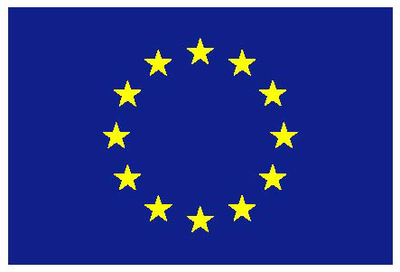
eContentplus

This project is funded under the eContentplus programme,
a multiannual Community programme to make digital content in Europe more accessible, usable and exploitable.
Table of Contents

1. Summary 3
2. Status 4
2.1 GANTT Table 4
2.2 Work Package 1 – Project Management 6
2.3 Work Package 2 – Content selection, metadata alignment,
knowledge management 9
2.4 Work Package 3 – Digitisation, metadata entry, API and web 11
2.5 Work Package 4 - Awareness and Dissemination 13
2.6 Work Package 5 - Assessment and Evaluation 18
3. Deliverables Status 20
4. Conclusions 21
Annex 1: List of Academic Advisory Group Members 22
Annex 2: Visitors’ statistics through Googleanalytics 23
Annex 3: Judaica Europeana Metadata Ingestion Plan 28
Annex 4: Highlights of Dissemination and Awareness activities 34
4.1 Conferences, workshops and other events 34
4.2 Project brochure 37
4.3 Judaica Europeana Newsletter 1 and 2 38
Annex 5: Evaluation report on Digital Humanities Workshop 39

1. Summary
JUDAICA EUROPEANA supports Europeana, the European Digital Library, to reach a comprehensive coverage of the theme of Cities. Jews occupied a central role in the evolution of the modern city; their presence and stake in urban culture has been so high as to render them the symbolic equivalent of the city itself. The project is anchored in a network of leading European institutions with substantial content holdings that document Jewish contribution to the development of European cities. Its objectives are:
- to encourage and support holders of Jewish content to identify elements of their collections that document the role, creativity and self-expression of Jews in European Cities so that this content may be processed and integrated into Europeana under the theme of Cities.
- to support the digitisation of such content (when required) and its aggregation into a virtual coherent thematic collection able to be fully integrated into Europeana.
- to coordinate standards across the participating institutions and holders of such thematic content in view of their harmonization to the metadata and interoperability requirements of Europeana.
- to identify, evaluate and support the implementation of a set of knowledge management tools. The deployment of such tools will enable the underlying community of practice to adapt and apply controlled vocabularies, thesauri and ontologies for the indexing, retrieval and re-use of the aggregated content in the area of interest.

JUDAICA will (1) provide substantial digitised resources for EUROPEANA (2) increase the re-use of such resources through an energetic dissemination (3) disseminate the use of standards assuring the compatibility of content to EUROPEANA requirements and demonstrate semantic interoperability (4) Involve the relevant community of knowledge and practice in a pilot that will demonstrate the added value of digital access in the thematic domain for scholarship and curatorial purposes.

JUDAICA will digitise a large quantity of books, newspapers and archives and press clippings. It will also digitise photos, postcards and recordings. It will also seek to involve additional Associate Partners who hold digitised resources on the thematic domain,

The present report covers the first year of the project life-time, namely from 1/01/2010 until 31/12/2010.

During the reported period, Judaica Europeana has contributed to all the above mentioned objectives, as specified in the following pages. The management and coordination tasks have been implemented effectively with due respect to the contractual tasks requested by the European Commission and in parallel with the dissemination and awareness actions. The work of Judaica Europeana is carried out in the frame of its five work packages.

2. Status

2.1 GANTT Table
The following table presents the overall plan of activities of the project. Please note that this GANTT table presents the correct distribution of project activities, derived from the latest version of the Description of Work:

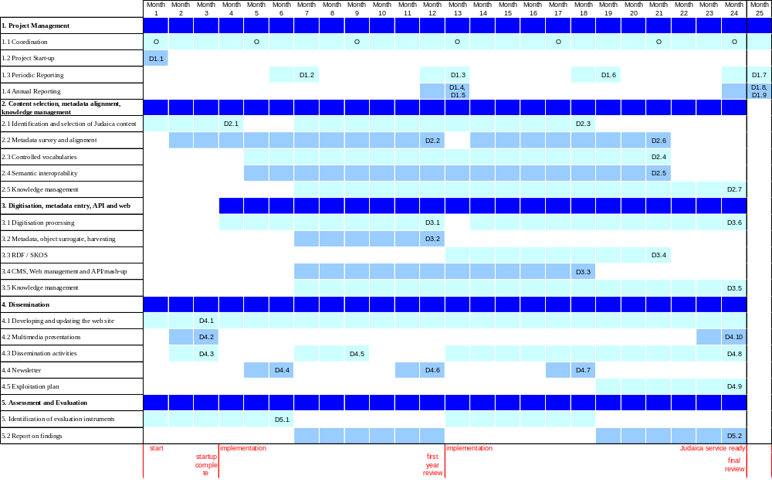

2.2 Work Package 1 – Project Management
Work package Description

Work package number : | 1 | Start date: | 0 | End date: | 24
Work package title: | Project Management

Objectives for the period
To effectively manage the project to deliver the solutions developed in the Work Packages on time, to maintain cost and quality in accordance with the requirements of the grant agreement between the Commission and the project consortium. This will be done by providing: internal management and financial/administrative control of the project; planning of external strategic co-operation activities; building of both informal and formal relationships with other relevant projects and initiatives.

Description of work carried out and achievements
This WP is led by the European Association for Jewish Culture
This work package provided the administrative and organisational capacity for the project start-up, implementation and development. It managed the coordination with the European Commission and ensured the communication and the circulation of information among the partners and organized partners’ meetings. It monitored and supported the work of the other work packages. Among the activities carried out during the reporting period, the following should be noted:

- Development and revision of working plans: all Work Packages reviewed their working plans in the light of ongoing work and issues arising. The solutions to technical challenges in respect of metadata ingestion were developed and corrective actions agreed.. In this way the project is able to keep the activities under control, preventing delays and taking the necessary corrective actions.

- Consortium agreement: a Consortium agreement was prepared and signed by the partners.

- Associate Partner agreement: an Associate Partner agreement has been drafted and approved by the Consortium. It is now the standard document that additional institutions willing to join the project as associate partners are required to sign.

- Co-option of Associate Partners: WP1 researched and identified potential associate partners with the aim of aggregating their collections in Judaica Europeana. Our approaches resulted in 11 new institutions agreeing to join the Judaica Europeana network; 2 more will join in the new year. This effort continues and we expect that more institutions will join (see report below under WP4). Progress depends on the extent to which the collections of the prospective partners have been digitized. The list of associated partners to-date is available on our home page at http://www.judaica-europeana.eu/

- Organisation of plenary meetings with all WP Leaders and partners. The following meetings were organised ( minutes and presentations are available in the reserved area):
- 2010-01-25/26 London, UK Kick-off meeting
- 2010-05-10/11 London, UK 2nd Steering Committee and WP meetings
- 2010-07-27 Ravenna, 3rd Steering Committee and WP meetings
- 2010-11-15 Jerusalem, 4th Steering Committee and WP meetings

Meetings of WP Leaders were organised in order to coordinate activities. These meetings were held through online conferencing facilities.

- Mailing list: the Judaica@amitie.it mailing list has been set up and serves for the announcements and exchanges with all the partners and other personnel directly related to Judaica Europeana. With the increase of the number of associated partners an additional mailing list, judaicaassociates@amitie.it was established.

- Activation of a back office area within the project’s website, in order to share all reserved documents among the partners. The back office includes Moodle elearning facilities that the WPs may decide to use in the future. Username and password to access the reserved area are available to the European Commission. See: http://project.judaica-europeana.eu
See below the screen capture of the Judaica Europeana back office.
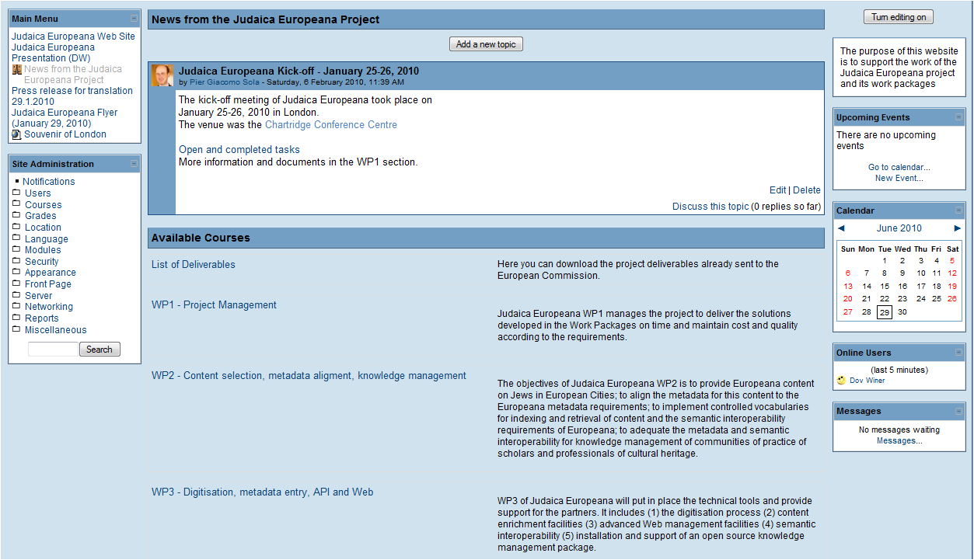
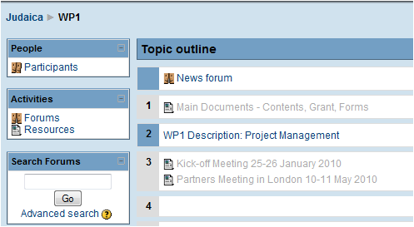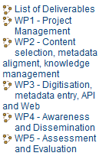

- Formation of the Academic Advisory Group (AAG). WP1 secured the cooperation of 14 academic experts in Jewish studies at various leading universities. The meeting of the AAG was organized on 29 July in Ravenna when the experts discussed selection criteria, dissemination to universities and evaluation. The list of AAG members is attached to this report in Annex 1.

- Keeping in touch with the Europeana management: WP1 coordinator has been in regular contact with the Europeana Team: Julia Brungs, Martina Schoberova, Anne Marie Gerwaen, Jon Purday. Judaica’s WP1 and WP3 have met and been in contact with Europeana’s technical team regarding metadata uploading. Judaica Europeana Management Team participated in Europeana conferences and Working Group meetings. WP1 Coodinator is a member of the Europeana Council of Aggregators.

- Cooperation with other projects from the Europeana cluster: (1) There have been regular contacts with the Athena project regarding the use of the Athena ingestion tool. Judaica Europeana representatives have participated in relevant Athena events; the training materials developed by Athena have been used by Judaica Europeana partners (2) The materials produced by the IMPACT project (British Library, partner in Judaica) were used by Judaica partners for reference. (3) Judaica Europeana representatives participate in WP3 of the Europeana V1.0 project, which is developing the new Europeana Data Model. (4) Contacts have been made with the EOD network (eBooks on Demand) http://www.books2ebooks.eu/partner.php5; with the APEnet and EuropeanaLocal projects. (5) Judaica Europeana representatives have participated in the meetings of Europeana Comms Group.

- The deliverables D1.1, D1.2, D1.3 and D1.4 (the present one) have been prepared and delivered to the Commission on time.
.

Deviation from work plan & remedial action
None.

2.3 Work Package 2 – Content selection, metadata alignment, knowledge management
Work package Description

Work package number : | 2 | Start date: | 0 | End date: | 24
Work package title: | Content selection, metadata alignment, knowledge management

Objectives for the period
In order to provide EUROPEANA with a critical mass of content:
- To identify and select in the collections of the partners and Associated Partners a critical mass of cultural heritage resources that belong to the thematic domain, “Jews in European Cities”, to be digitised.
- To identify already digitised resources that belong to the same domain with a view to align the metadata for this content to the EUROPEANA metadata requirements (ESE, Europeana Semantic Elements)
- To survey the existing metadata schema that are now being applied by the partners for the description of their digitised resources.
- Define and implement the necessary steps to align these schemas to the Metadata requirements defined for Europeana.

Description of work carried out and achievements
This WP is coordinated by partner 2 UB-FFM

- Audit on Judaica Europeana content including metadata

This WP developed a detailed questionnaire (available at the Judaica Europeana back office, in the WP2 section) to support:
- A detailed audit, assessment and selection of content to be digitised at the partner institutions’ collections. Including analysis of quality and types of resources/assets, copyright and IPR issues, quantified targets for digitisation.
- A detailed audit of available digitised resources.
- Survey the existing metadata schema that are currently being applied by the partners for the description of their digitised resources;

The partners carried this detailed audit and filled the questionnaire. These replies served for the preparation of the deliverable D2.1 Audit report on Judaica content including metadata, 1st version - delivered in M4.
Following the initial survey further work was carried out to provide an accurate appraisal of content provided by the partners of Judaica Europeana and the metadata in use. The survey made apparent the multiplicity of standards and wide range of metadata in use. The Judaica Europeana partners include libraries, archives and museums.
WP2 activities in this period of work were characterised by intensive exchanges and evaluation of the different metadata schema and how best to cope with the challenges involved in mapping such varied schemata to ESE (Europeana Semantic Elements).

Deliverable D2.2 – First Report on Content Metadata Alignment with Europeana Requirements - which express the result of these endeavours was delivered in time.

- Controlled vocabularies for semantic interoperability applications. At a later stage of the project, this WP is expected to identify and select controlled vocabularies in the thematic domain area and adapt them for Judaica Europeana purposes; such vocabularies will be sought in a larger context – the survey indicates that few such vocabularies are used in the partner institutions.
The new Europeana Data Model (EDM) was presented at the meeting of Europeana V1.0 WP3 in Pisa on June 14-15. The central role of vocabularies in EDM is dramatically expressed in the EDM related documentation and the discussions held at that meeting. Following it, WP2 of Judaica Europeana prepared a detailed internal deliverable concerning vocabularies. This deliverable details the motivation behind the work on vocabularies; the main concepts involved; and concludes with a program of work in the area of Jewish related vocabularies concerning Who (Names), When (Periods) and Where (Places). This internal deliverable – Jewish semantics in the Linked Data Semantic Web – Vocabularies – is available at
http://www.judaica-europeana.eu/docs/jewish_vocabularies_LOD.pdf

- Academic Advisory Group, The first meeting of the committee took place during the Ravenna Congress of the European Association for Jewish Studies on July 29, 2010. Prof. Antony Polonsky has accepted to serve as Chair of this committee composed by leading scholars who are involved in research and teaching of Jewish History and culture. They agreed to provide general guidance, help disseminate to universities for teaching and research purposes, and provided evaluation of the academic and dissemination aspects of the project.

Deviation from work plan & remedial action
None.

2.4 Work Package 3 – Digitisation, metadata entry, API and web
Work package Description

Work package number : | 3 | Start date: | 4 | End date: | 24
Work package title: | Digitisation, metadata entry, API and web

Objectives for the period
WP3 objectives for this initial period were:
- To put in place the technical tools required for JUDAICA tasks and provide support for Partners and Associated Partners.
- Provide advanced web management facilities based on open source CMS.
- Supporting the partners in digitising the recources in their physical collections selected under the thematic domain.
- Assure that the digital object surrogates and the metadata are compliant with the requirements of Europeana including their transfer based on XML structured files. Provide an metadata entry system through which partners are able to upload their metadata to Europeana. Enabling the harvesting of the metadata recoreds via OAI-PMH.

Description of work carried out and achievements
This WP is coordinated by the AIU partner.

- Web site. Facilities for management of the public Web site of the project were established. Due to the preferences of the Webmaster and other practical considerations it is presently managed using the DreamWeaver package instead of an open source CMS initially foreseen. The back office is maintained using the Moodle open source package.
- Support to partners concerning the digitisation process. WP3 assembled relevant documentation that provides tutorials and step-by-step support to the partners in planning and implementing the full cycle of the digitisation process. References to such documents were included in the presentation of Jean-Claude Kuperminc (AIU) at the second plenary meeting that took place in London on May 10-11. The British Library, one of Judaica Europeana partners, presented the work it is leading in developing Decision Support Tools in the framework of the IMPACT project. This work is described in the deliverable D3.1 that was delivered by WP3 on time.

- Metadata ingestion facilities. The active involvement of MiBAC led to close cooperation with the ATHENA project. This enabled WP3 to set metadata ingestion facilities for each of the project partners at the experimental server; a task coordinated by David Klein from the AIU. David, after taking part in a relevant training workshop on the use of the metadata ingestion facilities has been an active participant in the mailing list discussions on how to overcome the current problems experienced in the process of mapping metadata schemata to LIDO and ESE. The operational metadata ingestion facilities were inaugurated last May; it is expected that Judaica Europeana partners will begin to upload their metadata in early autumn 2010. This still depends on (1) overcoming the obstacles for mapping MARC 21 to ESE (2) the support for mapping and ingesting metadata from archives in September. This will be achieved following the implementation of the APENET/ATHENA cooperation.

- Mapping metadata and training for the partners. During this period WP3 has collected from the partners XML samples of their metadata. It has carried detailed mapping exercises in which the partners were instructed in the use of the Athena metadata ingestion tool using a hands-on approach.

- Metadata ingestion facilities. During this period, WP3 dealt with the challenges posed by the wide diversity of institutions (libraries, archives and museums) from which metadata needs to be uploaded to Europeana. This variety is reflected in the structural characteristics of the metadata they provide.
WP3 planned to use the metadata ingestor developed by Athena, a project lead by MiBAC which has major responsibilities in WP3. However the plans of Athena to adapt its metadata ingestor to the popular MARC 21 metadata schema of Libraries and to the hierarchical characteristics of Archives metadata have not been carried out.
The source of the difficulties was due to the fact that Athena is adapted exclusively for the ingestion ofmetadata of museums and makes use of the LIDO metadata schema.
- At the end of the period the following solutions were found with through the active involvement of MiBAC:
- An OAI-PMH metadata harvester server will be installed to carry out the harvesting of metadata from the libraries of the partners of Judaica Europeana.
- Metadata from the Museums will be uploaded throught the Athena metadata ingestor
- Metadata from the Archives will be delivered manually (using disks) as XML files to be provided directly to the Europeana ingestion team.
Summary of the work is to be found in the deliverable D3.2 - Report on the metadata entry systems of the partners and the procedures for adapting Judaica metadata to Europeana requiredments – which was prepared during this period and delivered on time.

Deviation from work plan & remedial action
The ingestion of 100,000 metadata records that was scheduled to be carried out by December 2010 has been postponed to January 2011. This was due to the difficulties experienced in using the Athena metadata ingestor for records whose provenance is in libraries.

2.5 Work Package 4 - Awareness and Dissemination
Work package Description

Work package number : | 4 | Start date: | 0 | End date: | 24
Work package title: | Awareness and Dissemination

Objectives for the period
- To raise awareness of the project and promote its results.
- To promote the JUDAICA Europeana content to the different constituencies across Europe and motivate scholars, teachers and students, cultural heritage professionals to turn to JUDAICA as their primary resource.
- To promote the JUDAICA system and EUROPEANA to a wider group of public and private content owners and to secure the support of Associate Partners that will contribute additional resources/assets to the project.
- To ensure synergy between the JUDAICA dissemination and EUROPEANA

Description of work carried out and achievements
WP4 is coordinated by the European Association for Jewish Culture (EAJC)

- Multimedia project presentation of the project
A multimedia powerpoint presentation of the project was developed and made available on the public website of the project. It has been presented at many meetings and conferences.
Other variants of this presentation were prepared, adapted to the needs of the different events at which the project was presented.

Newsletter
The first Judaica Europeana newsletter was published according to the DoW schedule and distributed through mailing lists. The Newsletter was highlighted by Europeana in their own news service. It is available at http://www.judaica-europeana.eu/Newsletter_1_2010.html

At the end of this reporting period, the second illustrated Judaica Europeana newsletter (Deliverable D4.6) was published and is available at http://www.judaicaeuropeana.eu/Newsletter.html
This 5-page publication presents objects and stories from the Partners’ collections, features two virtual exhibitions, and reports on the growing Judaica network, and the conferences and events held in the last 6 months. The newsletter has been distributed to the subscription list which is based on requests from visitors to the website or readers of the first newsletter. Judaica Partners will distribute it through their website and email lists, other special target lists and websites in the new year. Europeana’s twitter post will stimulate further interest.

- Press release: Following the establishment of the public web site a press release was prepared and distributed through various channels. It was translated by the partners and distributed internationally and locally. This was carried out in coordination with the Communication Team of Europeana. The results were very good in terms of the number of news agencies and web sites that relayed the announcement as well as in terms of the interest it aroused. Several institutions contacted the Coordinators of the project to explore possible collaboration.

- A project brochure was produced in advance of the due date of this D4.5 deliverable (M9) in order to begin distribution at major conferences.

- Public web site for the project
An attractive website for the project was developed and continues to be updated. It serves as the main platform for the dissemination activities of Judaica Europeana. Improvements to the website include the RSS news feed from Europeana and embedding of conference videos, improved navigation, introduction of a music clip on the home page and short features and linsk to partners virtual exhibitions. A more detailed sitemap was also produced. The site is available at http//:www.judaica-europeana.eu

- The visitors’ statistics are monitored through Googleanalytics. A screen capture of its main page follows:

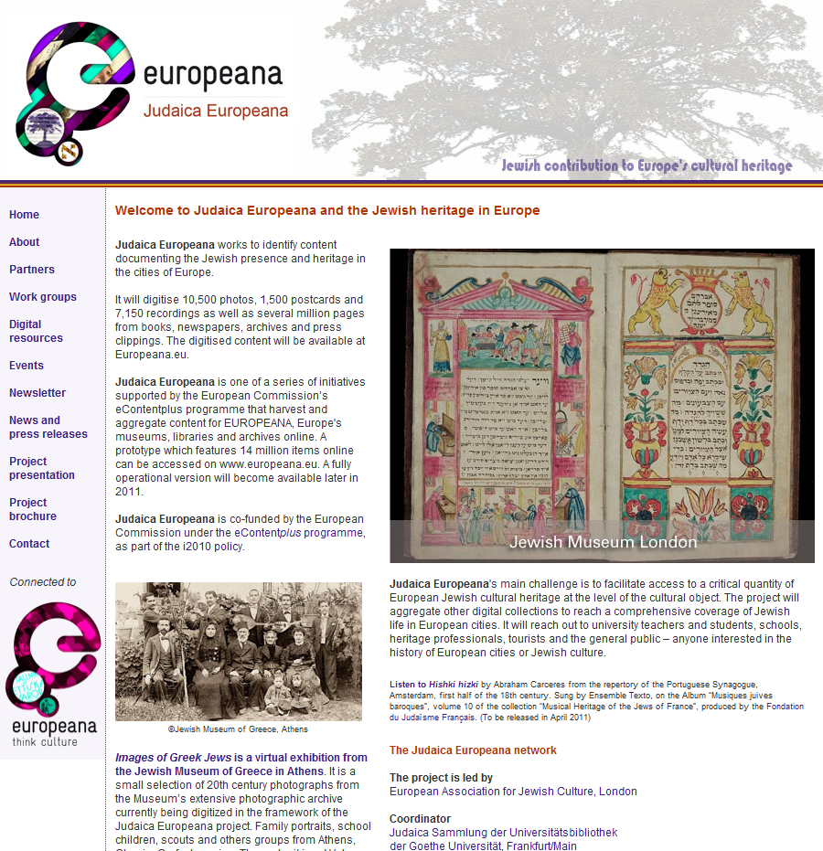

The visitor’s statistics are monitored through Googleanalytics and more detailed reports are attached in Annex 2. The headline statistics since the launch of the website on 7.2.10 up to 31.12.2010 are as follows :
Visits 12,410
Visitors 8,641
Pageviews 24,986
Average time on site 00:04:53

We expect that the distribution of the second newsletter after the Christmas/new year holiday will stimulate further traffic to the website.

- Engaging additional associated partners
During the reporting period, WP4 made significant efforts to involve additional institutions as associated partners. This effort provided substantial results: the Judaica network has acquired 11 new associate partners:
- Ben Uri Gallery – The London Jewish Museum of Art
- Center for Jewish History, New York
- Jewish Historical Museum, Amsterdam
- Jewish Museum Berlin
- Jewish Museum, Frankfurt/Main
- National Library of Israel, Jerusalem
- Paris Yiddish Center—Medem Library
- Sephardi Museum, Toledo
- Central Zionist Archives, Jerusalem
- Ministerio de Cultura, Madrid
- Salomon Ludwig Steinheim Institute, Duisberg

The following institutions are currently in discussion with us about joining:
- Aberdeen University Library
- Jewish Museum of Belgium, Brussels
- Jewish Community Library and Archives, Venice
- Magnes Collection of Jewish Art and Life, Berkeley
- Royal Library of Denmark
- National Museum, Krakow
- London Metropolitan Archive
- Mantua City Archives

- Detailed dissemination plan. During this reporting period the partners, as part of their WP4 tasks, developed a detailed dissemination plan. The plan, following the DoW, outlines how the partners intend to involve additional associate partners in the project and how to engage the different target populations in using the Judaica Europeana resources. These include research scholars; university teaching; cultural heritage professionals; school education; tourism and the wider public. The dissemination plan resulted in the deliverable D4.3 of March 31, 2010.

- Conferences, seminars and workshops. An extensive programme of conferences, seminars and workshops as well as presentations at international events was implemented: 21 events and presentations were held were held in 14 different cities. The highlights included a Judaica session on Jewish urban studies at the 9th Congress of the European Association for Jewish Studies in Ravenna; a Workshop on Digital Humanities at the same Congress; an International Judaica Europeana conference in the conjuction with the EVA-Minerva International Jerusalem Conference on Digitisation of Culture, a presentation to the Annual Conference of the Association of European Jewish Museums in Rome and presentations at Europeana conferences in Berlin, Edinburgh and Madrid (EuropeanaLocal). Judaica’s multimedia project presentation was further developed and adapted to the interests of particular audiences.

A full list of events with links to a number of presentations is available at
http://www.judaica-europeana.eu/events.html

- Virtual exhibitions. Best practice guidelines on planning, designing and marketing of virtual exhibitions were presented and discussed at WP4 meetings (May and November 2010). Two virtual exhibitions were produced by Judaica partners in the period under review:
- Jewish postcards: Networking in Europe produced by the Hungarian Jewish Archives, Budapest http://milev2.2kal.hu/exhibits/show/networking-in-europe
- Images of Greek Jews produced by the Jewish Museum of Greece, Athens
http://www.jewishmuseum.gr/en/activities_dynamic/news/item/5.html

The exhibitions can be accessed on the Partners’ websites or through the Judaica Home page. They are also featured in the Judaica second newsletter. Other virtual exhibits will be produced in the course of 2011.

Deviation from work plan & remedial action
A few virtual exhibitions have been delayed however preparations for these exhibitions are well advanced for 2011.

2.6 Work Package 5 - Assessment and Evaluation

Work package number : | 5 | Start date: | 0 | End date: | 24
Work package title: | Assessment and Evaluation

Objectives for the period
To carry out, in collaboration with other work packages, a process-oriented project evaluation and report on the findings.
To plan a comprehensive evaluation showing how the addition of the thematic domain content by JUDAICA may lead to an improved practice in the discovery, delivery, integration of cultural heritage resources for European target populations: scholars, cultural heritage professionals, education users, cultural tourists and the general public.

Description of work carried out and achievements
WP5 is coordinated by Amitie.

During the period of this report the following has been accomplished:

- Identification of success factors Potential target users and their needs were identified and divided into three main categories so as to better focus future surveys. A similar approach was adopted in WP4 to define communication channels and increase effectiveness. Building strong contacts with the main target groups is a good way to gain an insight in the users’ perspectives and to measure usability.

- Identification of evaluation instruments and planning. An evaluation plan was designed together with a first set of evaluation tools. The plan lays down the methodology and identifies the actors involved in quality monitoring. The areas of activity considered for evaluation cover project management performance, communication/dissemination, sustainability as well as the quality of outcomes. It was presented to the partnership in occasion of the kick-off meeting.

- Analysis of quantitative and qualitative data. A regular evaluation of the project management has been carried out and the results shared with both the project co-ordinator and the partners. Since the beginning the following meetings have been evaluated:
- the consortium meeting in Chesham (UK) on the 11th May 2010.
- the consortium meeting in Ravenna (Italy) on the 27th July 2010.
- the consortium meeting in Jerusalem (Israel) on the 15th November 2010.

- The second tool for event evaluation have been deployed in several occasions that took place during this period:
- The Academic Advisory Committee meeting in Ravenna on July 29th 2010
- The Digital Humanities Workshop held in Ravenna on July 30th 2010
- The International Judaica Europeana conference sessions on November 16th 2010
The information collected in these opportunities provides feedback to the project management and the partners and will inform the deliverable D5.2 to be issued at the end of the project.

Deviation from work plan & remedial action
None.

3. Deliverables Status
Deliverable  No | Deliverable title | Delivery due  date | Actual date of delivery
D1.1 | Gantt chart of project activities with critical path | M1 | M1
D4.1 | Project public web site | M3 | M3
D4.2 | Multimedia project presentation | M3 | M3
D4.3 | Dissemination plan | M3 | M3
D2.1 | Audit report on JUDAICA content including metadata (1st Version) | M4 | M4
D4.4 | First Newsletter | M6 | M6
D5.1 | Evaluation methodology & targets | M6 | M6
D1.2 | First progress report | M7 | M7
D4.5 | Project brochure and the 1st of the Workshops to be held at a major conference. | M9 | M9
D2.2 | First report of content metadata alignment with Europeana requirements | M12 | M12
D3.1 | Report on the digitisation of the resources provided by partners (1st version) | M12 | M12
D3.2 | Report on the metadata entry systems of the partners and the procedures for adapting Judaica metadata to Europeana requirements | M12 | M12
D4.6 | Second Newsletter | M12 | M12
D1.3 | Second progress report | M13 | M13
D1.4 | Annual Report | M13 | M13

4. Conclusions
The first year of activities of Judaica Europeana established successfully the basic structures and processes of the project and succeeded in advancing the project’s objectives. The project made good progress with the identification of relevant content, preparing for and beginning the digitisation of the partners resources, the preparation of the metadata and experimenting with the use of the ingestion tools for uploading to Europeana. The project developed considerable interest in Judaica Europeana among its target audiences.

At the same time, the project has sought to acquire the expertise and the tools concerning controlled vocabularies and a possible pilot for the application of knowledge management tools by scholarly groups and /or communities of practice.

The project had to deal with the challenges posed by the diversity of its partners coming from different institutional areas and domains such as libraries, archives and museums. This fact has demanded that the ingestion of metadata to Europeana be adapted to the constraints of the different metadata systems held by the partners.

The project is following closely Europeana development of its new data model and is seeking to establish an ambitious program of work concerning controlled vocabularies for Jewish content. Judaica has sought through two digital humanities related workshops to get the tools for a possible pilot in the application of knowledge management tools by scholarly groups and /or communities of practice.

A large number of dissemination activities has been carried out. A substantial number of associate partners have been included in the project. Several more are expected to join in the coming months.

All the deliverables have been prepared and delivered on time.

Annex 1: List of Academic Advisory Group Members

Chair: Professor Antony Polonsky
Near Eastern and Judaic Studies, Brandeis University, Cambridge, Mass.

Professor Michael Brenner
Jewish Studies and Culture, University of Munich

Professor Nicholas de Lange
Hebrew and Jewish Studies, University of Cambridge

Dr Anna Foa
Department of History, La Sapienza University, Rome

Professor Gershon Hundert
Jewish Studies, Mc Gill University, Montreal
Editor of The YIVO Encyclopaedia Jews in Eastern Europe

Dr François Guesnet
Department of Hebrew and Jewish Studies, University College London

Professor Rudolf Klein
Architectural historian, Saint Stephen’s University, Budapest

Dr Gadi Luzatto Voghera
Department of Historical Studies, Università Ca' Foscari di Venezia and Centre for Italian and European Studies, Boston University Padova Program; Director, Jewish Library and Archives in Venice

Professor Michael L Miller
History Department, Central European University, Budapest

Dr Laura Mincer
Rabbinical College, Rome

Simon Tanner
Director, Centre for Computing in the Humanities, Kings College London

Professor Giuseppe Veltri
Jewish Studies, Martin Luther University of Halle-Wittenberg

Professor Marcin Wodzinski
Centre for the Culture and Languages of the Jews, University of Wroclaw

Dr Gerben Zaagsma
Yiddish studies and Yiddish resources on the web, University College London

Annex 2: Visitors’ statistics through Googleanalytics
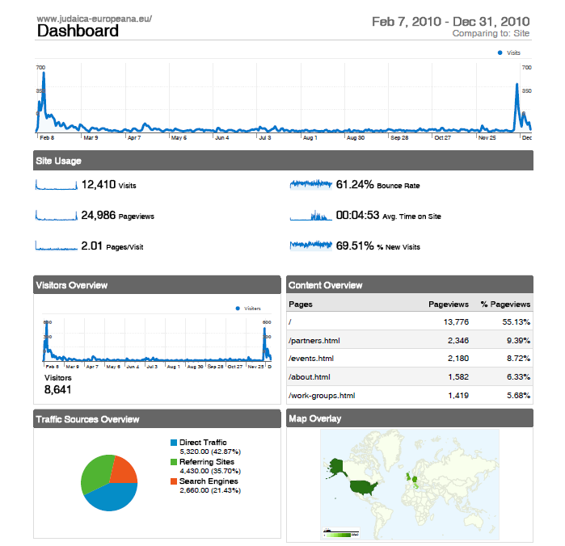
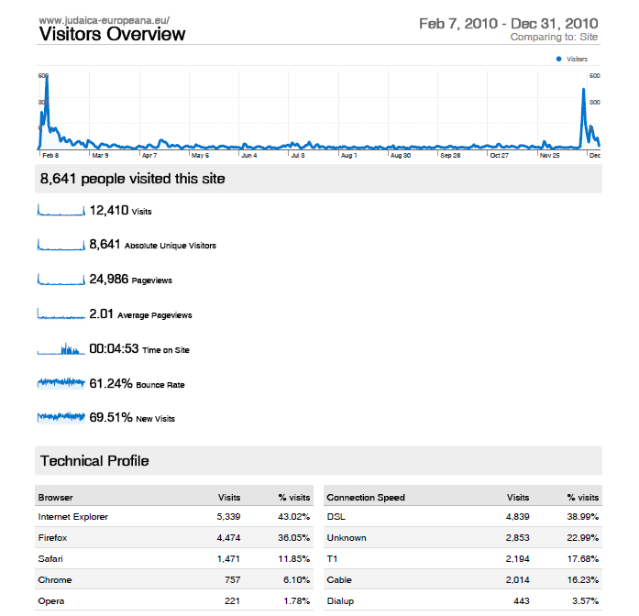
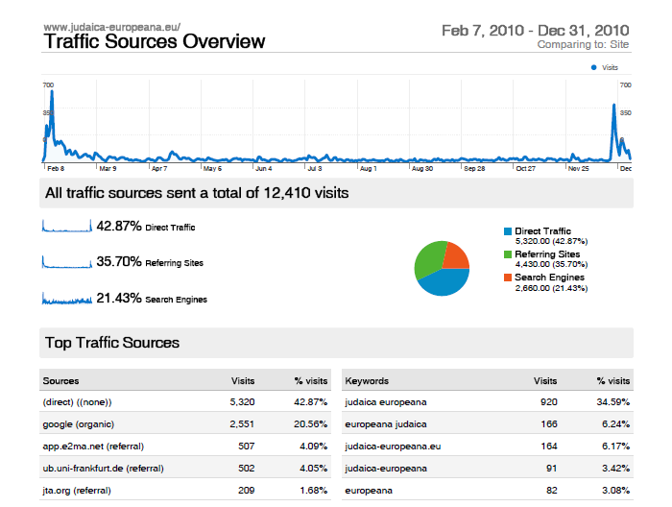
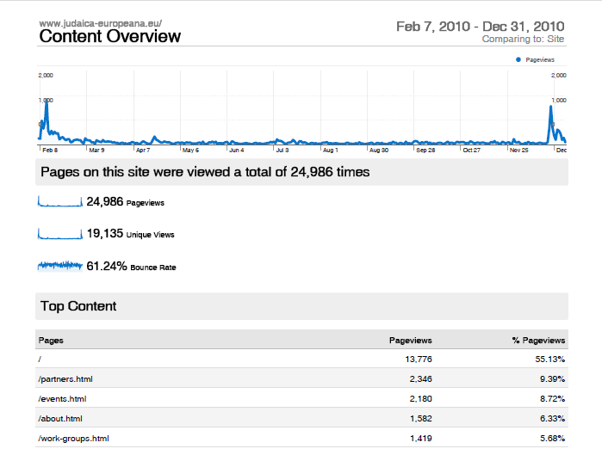
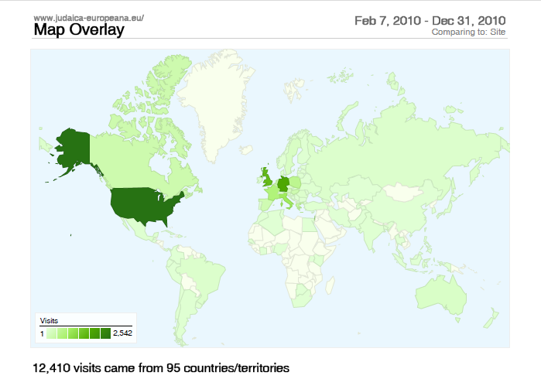

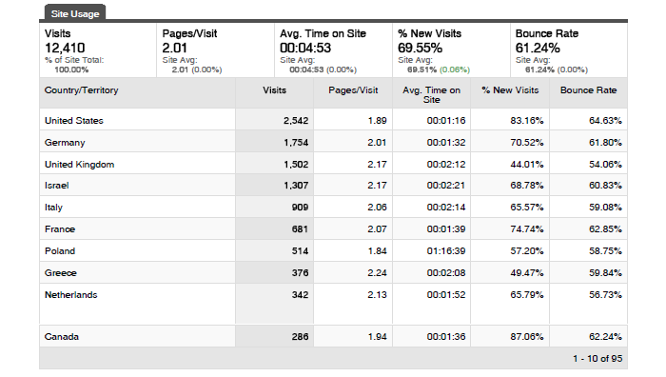

Annex 3: Judaica Europeana Metadata Ingestion Plan
Content to be digitized by the providers

Content Provider
 | Collection Name | Type of object | Qantity in pages | Format | Metadata | IPR | Export to XML
Frankfurt University Library/ Judaica
 | Frankfurteriana | Paper | 200.000 | Text | MAB 2 | Public Domain | yes
 | Freimann-Collection, Part II | Paper | 500.000 | Text | MAB 2 | Public Domain | yes
Alliance Israelite Universelle
AIU-Library | Jewish Periodicals, 19th &20th century | Paper | 1.000.000 | Text | Marc 21 | Public Domain | yes
 | Jewish Journals, 20th century | Paper | 200.000 | Text | Marc 21 | AIU + consent | yes
 | Books | Paper | 30000 | Text | MARC 21 | Public Domain | yes
 | Photo-Collection | Paper | 5000 | Image | File Maker Pro | AIU | Conversion into MARC 21 Data
 | Film Collection | Film | 8 films x 3-45 mn | Video | not yet-Aleph Marc 21 | AIU | yes
AIU-Archives | Archival Material | Paper | 1.000.000 | Text | EAD, EAC | AIU | yes
Medem Library
 | Records of Jewish songs | mp3 | 6.000 | Audio | Marc 21 | only 643 Medem | yes
 | Yiddish Books | Paper | 78.500 | Text | Marc 21 | Medem | yes
 | Photo-Collection | Paper | 1.000 | Timage | Marc 21 | Medem | yes
Jewish Museum of Greece
 | Books -Titlepages | Paper | 648 | Text | In house | JMG | yes
 | Books, complete | Paper | 2.300 | Text | In house | JMG | yes
 | Manuscripts | Paper | 107 | Text | In house | JMG | yes
 | Archival material -Documents | Paper | 1150 | Text | In house | JMG | yes
 | Postcards | Paper | 25 | Text | In house | JMG | yes
 | Religipus Artifacts | Object | 596 | Image | In house | JMG | yes
 | Textiles | Object | 403 | Image | In house | JMG | yes
 | Costumes | Object | 478 | Image | In house | JMG | yes
 | Domestic Artifacts | Object | 477 | Image | In house | JMG | yes
 | Personal Objects | Object | 400 | Image | In house | JMG | yes
 | Ephemera | Object | 99 | Image | In house | JMG | yes
 | Etchings | Paper | 94 | Image | In house | JMG | yes
 | Photo-Collection -Archive | Paper | 2673 | Image | In house | JMG | yes
 | Photo-Collection | Paper | 873 | Image | In house | JMG | yes
 | Coins | Object | 125 | Image | In house | JMG | yes
 | Architectural Elements | Object | 27 | Image | In house | JMG | yes
 | Contemporary Artworks | Object | 47 | Image | In house | JMG | yes
 | Arditis Archives | Paper | 230 | Text | In house | JMG | yes
 | Patras Archives | Paper | 2740 | Text | In house | JMG | yes
 | Molho Archives | Paper | 110 | Text | In house | JMG | yes
 | Florentin Archives | Paper | 60 | Text | In house | JMG | yes
 | Yoel Archives - Documents | Paper | 270 | Text | In house | JMG | yes
 | Yoel Archives - Photos | Paper | 45 | Image | In house | JMG | yes
 | Hidden Children - Photos | Paper | 340 | Image | In house | JMG | yes
 | Jewish Neighbourhoods-Photo | Paper | 150 | Image | In house | JMG | yes
 | WWII and Holocaust-Photo | Paper | 376 | Image | In house | JMG | yes
 | Holocaust Survivors | Paper | 55 | Image | In house | JMG | yes
 | Young People | Paper | 420 | Image | In house | JMG | yes
 | Ioannina -Collection | Object | 270 | Image | In house | JMG | yes
Hungarian Jewish Archives
 | Dohany Street Synagoge-Pews | Paper | 2900 | Text | In house | HJA | yes
 | Jews of Pest - Conscription | Paper | 1761 | Text | In house | HJA | yes
MIBAC
Bibliotheca Palatina di Parma
 | Incunabula | Paper |  | Text | Dublin Core - MAG | Public Domain | yes
 | 16th Century Books | Paper | 48.000 | Text | Dublin Core - MAG | Public Domain | yes
State Archive Venice
 | Jewish Welfare - Registers 1581-1799 | Paper | 9 registers | Text | EAD | Public Domai | yes
 | Regulations for Jews1516-1799 | Paper | 3 files | Text | EAD | Public Domain | yes
 | Jews- 1750-1796 | Paper | 20 files + 1 register | Text | EAD | Public Domain | yes
- | Documents on Jews 1705-1795 | Paper | 26 files = 1 + 55 registers | Text | EAD | Public Domain | yes
 | Ghetto 1587-1647 | Paper | 1 register + 1 file | Text | EAD | Public Domain | yes
 | Jewish Necrology | Paper | 3 registers | Text | EAD | Public Domain | yes
 | Ghetto 1661-1740 | Paper | 4 registers | Text | EAD | Public Domain | yes
 | Politics towards Jews | Paper | 13 registers | Text | EAD | Public Domain | yes
 |  |  | 42.000
Jewish Historical Institute, Warsaw
 | Breslau, Electors registers | Paper | 4544 | Text | In house | Public Domain | yes
 | Breslau - Rabbinate | Paper | 2432 | Text | In house | Public Domain | yes
 | Burial Society | Paper | 41.912 | Text | In house | Public Domain | yes
 | Community members | Paper | 5057 | Text | In house | Public Domain | yes
 | Jewish cemeteries | Paper | 11.614 | Text | In house | Public Domain | yes
 | Jewish Theological Library | Paper | 8640 | Text | In house | Public Domain | yes
 | Jewish Charity | Paper | 42.070 | Text | In house | Public Domain | yes
 | Assoc. Of German Jews | Paper | 2027 | Text | In house | Public Domain | yes
 | Emigration | Paper | 1600 | Text | In house | Public Domain | yes
 | Schools | Paper | 4000 | Text | In house | Public Domain | yes
 | Registers of death | Paper | 1.863 | Text | In house | Public Domain | yes
 | Synagogues- documents | Paper | 6123 | Text | In house | Public Domain | yes
 | Administration 1791-1938 | Paper | 11.436 | Text | In house | Public Domain | yes
 | Jewish Communal Life | Paper | 4.306 | Text | In house | Public Domain | yes
 | Photo Collection | Paper | 90 | Image | In house | Public Domain | yes
Jewish Museum London
 | Audio Recordings | WAV and MP3 Cassettes | 150 | Audio | In house | JML | yes
 | Books | Paper | 6.000 | Text | In house | JML | yes
 | Art | Object | 30 | Image | In house | JML | Yes
 | Photos | Object | 300 | Image | In house | JML | Yes

Content already digitized by the providers

Content Provider
 | Collection Name |  | Type of object | Qantity in pages | Format | Quality | Metadata | IPR | Export to XML
Frankfurt University Library/Judaica Collection
 |  | Freimann-Collection | Paper | 750.000 | Text | TIFF & JPG | MAB 2 | Public Domain | yes
 |  | Yiddish prints | Paper | 200.000 | Text | TIFF & JPG | MAB 2 | Public Domain | yes
 |  | Compact Memory | Paper | 700.000 | Text | TIFF & JPG | Dublin Core | Public Domain | yes
Alliance Israelite Universelle
AIU Library |  | Books and Pamphlets | Paper | 16.000 | Text | 300 dpi, black &white, jpg | Marc 21 | Public Domain | yes
 |  | AIU Bulletins | Paper | 300.000 | Text | 300 dpi, grey scale, tiff | Marc 21 | AIU | yes
 |  | Photo Collection | Paper | 1.200 | Image | Tiff, 300 dpi,+ jpg 80 dpi, black&white | File Maker Pro | AIU | Conversion into Aleph Marc21
 |  | Film Collection | Film | 8 Movies, Wma | Video | Wma colour & black and white | File Maker Pro | AIU | Conversion into Aleph Marc21
Medem Library
 |  | Records of Jewish songs | mp3 | 4.876 | Audio | Marc 21 | only 643 Medem | yes
 |  | Yiddish Books | Paper | 20.000 | Text | Marc 21 | Medem | yes
 |  | Photo-Collection | Paper | 200 | Timage | Marc 21 | Medem | yes
Jewish Museum of Greece
 |  | Manuscripts | Paper | 90 | Text | TIFF and jpg | ESE v. 3.2. | JMG | yes
 |  | Documents | Paper | 1.000 | Text | TIFF and jpg | ESE v. 3.2. | JMG | yes
 |  | Textiles | Object | 6 | Image | TIFF and jpg | ESE v. 3.2. | JMG | yes
 |  | Coins | Object | 125 | Image | TIFF and jpg | ESE v. 3.2. | JMG | yes
 |  | Architectural Elements | Object | 24 | Image | TIFF and jpg | ESE v. 3.2. | JMG | yes
 |  | Photos | Paper | 873 | Image | TIFF and jpg | ESE v. 3.2. | JMG | yes
 |  | Etchings | Paper | 90 | Image | TIFF and jpg | ESE v. 3.2. | JMG | yes
 |  | Ephemera | Object | 80 | Image | TIFF and jpg | ESE v. 3.2. | JMG | yes
 |  | Personal Objects | Object | 30 | Image | TIFF and jpg | ESE v. 3.2. | JMG | yes
 |  | Religious Artifacts | Object | 54 | Image | TIFF and jpg | ESE v. 3.2. | JMG | yes
 |  | Costumes | Object | 12 | Image | TIFF and jpg | ESE v. 3.2. | JMG | yes
 |  | Contemporary Artworks -Paintings | Object | 47 | Image | TIFF and jpg | ESE v. 3.2. | JMG | yes
Hungarian Jewish Archives
 |  | Postcard | Paper | 1766 | Images | jpg 300 dpi colour | Inhouse | HJA | yes
Jewish Historical Institute, Warsaw
 |  | Breslau, Electors registers | Paper | 3694 | Text | TIFF, JPG 300 dpi | In house | Public Domain | yes
 |  | Community members | Paper | 1508 | Text |  | In house | Public Domain | yes
 |  | Administration 1791-1938 | Paper | 1.404 | Text |  | In house | Public Domain | yes
 |  | Jewish Communal Life | Paper | 1.716 | Text |  | In house | Public Domain | yes
 |  | Breslau-Representatives | Paper | 1307 | Text |  | In house | Public Domain | yes
 |  | Communal organization | Paper | 2260 | Text |  | In house | Public Domain | yes
 |  | Jewish families | Paper | 1021 | Text |  | In house | Public Domain | yes
 |  | Correspondence | Paper | 381 | Text |  | In house | Public Domain | yes
 |  | Jewish oath 1829-1869 | Paper | 268 | Text |  | In house | Public Domain | yes
 |  | Antisemitic incidents 1879-1895 | Paper | 526 | Text |  | In house | Public Domain | yes
 |  | Bulletin, correspondence 1924-1937 | Paper | 2812 | Text |  | In house | Public Domain | yes
 |  | Jewish Telegraphic Agency 1925 | Paper | 726 | Text |  | In house | Public Domain | yes
 |  | Properties and buildings 1919-1937 | Paper | 973 | Text |  | In house | Public Domain | yes
 |  | Christian Names 1836/37 | Paper | 24 | Text |  | In house | Public Domain | yes
 |  | Jewish Society of Friends | Paper | 179 | Text |  | In house | Public Domain | yes
 |  | Statutes | Paper | 1.428 | Text |  | In house | Public Domain | yes
Jewish Museum London
 |  | Album-pages | Paper | 203 | Text | JPG 150 dpi colour/grayscale | In house | JML | yes
 |  | Letters | Paper | 130 | Text | JPG 150 dpi colour/grayscale | In house | JML | yes
 |  | Theatre Programmes | Paper | 53 | Text | JPG 150 dpi colour/grayscale | In house | JML | yes
 |  | Leaflets | Paper | 41 | Text | JPG 150 dpi colour/grayscale | In house | JML | yes
 |  | Booklets | Paper | 3.200 | Text | JPG 150 dpi colour/grayscale | In house | JML | yes
 |  | Jewish Marriage Contracts | Paper | 28 | Text | JPG 150 dpi colour/grayscale | In house | JML | yes
 |  | Haggadah | Paper | 300 | Text | JPG 150 dpi colour/grayscale | In house | JML | yes
 |  | Posters | Paper | 20 | Image | JPG 150 dpi colour/grayscale | In house | JML | yes
 |  | Annual reports | Paper | 33 | Text | JPG 150 dpi colour/grayscale | In house | JML | yes
 |  | Certificates | Paper | 92 | Text | JPG 150 dpi colour/grayscale | In house | JML | yes
 |  | Books | Paper | 1.500 | Text | JPG 150 dpi colour/grayscale | In house | JML | yes
 |  | Business cards | Paper | 21 | Image | JPG 150 dpi colour/grayscale | In house | JML | yes
 |  | postcards | Paper | 34 | Image | JPG 150 dpi colour/grayscale | In house | JML | yes
 |  | Tickets | Paper | 16 | Image | JPG 150 dpi colour/grayscale | In house | JML | yes
 |  | Passports | Paper | 19 | Image | JPG 150 dpi colour/grayscale | In house | JML | yes
 |  | Photo-collection | Paper | 900 | Image | JPG 150 dpi colour/grayscale | In house | JML | yes
 |  | Membership documents | Paper | 200 | Image | JPG 150 dpi colour/grayscale | In house | JML | yes
 |  | Paintings | Paper | 100 | Image | JPG 150 dpi colour/grayscale | In house | JML | yes
 |  | Total |  | 5.500 | Text
 |  | Total |  | 1390 | Images

Annex 4: Highlights of Dissemination and Awareness Activities
Judaica Europeana Dissemination and Awareness activities during the first year included the following:

4.1 Conferences, workshops and other events
21 events featuring Judaica Europeana were held in 14 cities.

15 March 2010, Berlin
Digital Access to Jewish Heritage Collections: Judaica Europeana
Joint seminar with the Institut für Museumsforschung / Institute for Museum Research in Berlin. Presentations by Rachel Heuberger (Frankfurt) and Lena Stanley-Clamp (London)
21-24 April 2010, Florence
EVA 2010 Florence – Electronic Imaging in the Arts
Judaica Europeana: Semantic Web tools for expressing the contribution of Jews to European Cities in the European Digital Library – Europeana. Dov Winer
28 April, Jerusalem
Conference of the Israel Association of Judaica Librarians at the National Library of Israel
Keynote Address: 'Judaica Europeana' by Dov Winer, European Association for Jewish Culture
3-5 May, Tel Aviv
INFO 2010, the 25th Annual Conference & Exhibition
Dov Winer, European Association for Jewish Culture
Keynote address: 'The European Digital Library, Europeana and Judaica Europeana'
25-27 May, Amsterdam
WCIT 2010, World Congress of Information Technologies
Creative Industries Track
Dov Winer, European Association for Jewish Culture
Keynote address: Judaica Europeana - content, semantics and meaning for the creative industries'
28-30 May 2010, Bergen
COST A32 Open Scholarly Communities on the Web, eLearning Seminar
Dov Winer, EAJC and MAKASH
‘Contents from Europeana and Judaica Europeana for scholarship research and e-learning’
15-16 June 2010, Brussels
Judaica Europeana presentation at the LRE (Learning Resources eXchange) Technical and Semantic Interoperability Workshop
Organized by the European Schoolnet Learning Resource Exchange (LRE) and the ASPECT Best Practice Network
28 June 2010
Judaica Europeana presentation by Lena Stanley-Clamp at the Europeana UK Conference
Collections Trust, London
25-29 July 2010, Ravenna
Judaica Partners presentations on urban Jewish studies and Judaica Europeana
IX Congress of the European Association for Jewish Studies, Ravenna, Italy

30 July 2010, University of Bologna, Ravenna Campus
The Judaica Europeana Digital Humanities Workshop
co-sponsored by COST Action 32 Open Scholarly Communities on the Web
Digital Humanities Resources published at www.judaica-europeana.eu/digital-resources.html
Linked Open Data in Digital Humanities
Presentation by Christian Morbidoni and Michele Barbera
Everyday Digital Scholarship: using web-based tools for research
Presentation by Francesca di Donato
Open Scholarly Communities on the Web: quick start guide
Presentation by Matteo d’Alfonso
4-5 October 2010, Berlin
Europeana Germany Conference
Judaica Europeana presentation by Dr Rachel Heuberger
7 October 2010, Jerusalem
Workshop on Interedition, National Library and Judaica Europeana
Tools and methodology of digital scholarly edition and research
14-15 October 2010, Amsterdam
Europeana Open Culture Conference
19 October 2010, Poznań
Polish Digital Libraries Conference 2010: Europeana Day
Judaica Europeana presentation by Edyta Kurek
21 October 2010, London
Conference of European Association of Jewish Community Centres
Judaica Europeana presentation by Lena Stanley-Clamp
15-16 November 2010, Jerusalem
Judaica Europeana Conference at the EVA-Minerva International Conference on the Digitization of Cultural Heritage
1 November 2010, Budapest
Judaica Europeana presentation by Jean-Claude Kuperminc and Zsuzsana Toronyi at the Limmud 2010 annual conference
17 November 2010, Madrid
Judaica Europeana presentation by Carole Haskel at the Europeana Local National Conference
20-23 November 2010, Rome
Annual Conference of the Association of European Jewish Museums
Judaica Europeana and digitization of Jewish collections, presentation by Lena Stanley-Clamp
2-3 December 2010 Judaica Europeana Seminar, Jewish Museum of Greece, Athens
Teaching about the Holocaust in Greece. Judaica Europeana as a digital resource.
14 December 2010, Edinburgh
Judaica Europeana presentation by Elizabeth Selby at Collections Trust's Europeana Scottish Conference

We wish to highlight the following events:

The IX Congress of the European Association for Jewish Studies, 25-29 July 2010, Ravenna
which is held every 4 years with the participation of scholars from Europe, Israel, USA and elsewhere. The Judaica Europeana logo was printed on Conference bags and the brochure was distributed to all the participants. http://eurojewishstudies.org/congresses/judaism-in-the-mediterranean-context-ninth-eajs-congress-ravenna-25th-29th-july-2010/

Judaica Europeana organized a session on Jewish urban studies: three papers based on Judaica Europeana content were presented by the following partners: Rachel Heuberger (UBFFM); Jean-Claude Kuperminc (AIU); Zsuzana Toronyi (Hungarian Jewish Archives). The session was chaired a member of the JE Academic Advisory Group, Francois Guesnet (UCL). The abstracts were published in the Congress proceedings and presented in Newsletter 2.

Digital Humanities Workshop for the Congress participants, 30 July Ravenna
A Workshop on Digital Humanities was held to introduce Jewish studies scholars to the repertoire of open source digital tools available for research and teaching. The presentations were made by experts from Cost Action 32 and chaired by JE Academic Advisory Group Chairman, Antony Polonsky (Brandeis University). Presentations and a Digital Resources directory have been published on the Judaica website. Feedback questionnaires reported a high-level of satisfaction from the participants, who will be involved in the deployment of Judaica knowledge management activities.

Judaica Europeana Conference 16-17 November 2010, Jerusalem
Judaica Europeana Conference on JE digital content, technology and education within the EVA Minerva Conference was a first-class opportunity to involve the targeted audiences in the heritage, libraries and education sectors. http://www.digital-heritage.org.il/2010Program.html

Association of European Jewish Museums Annual Conference, 22-24 November, Rome
A presentation at a plenary session of the annual conference of the Association of European Jewish Museums reached out to the museums professionals and potential associate partners.
http://www.aejm.org/

4.2 Project brochure
The project brochure is available online in English, Italian, Greek and Polish at
http://www.judaica-europeana.eu/brochure.html
other language translations have also been produced as information sheets. The brochure has been distributed at:
- Institute for Jewish Policy Research Lecture, The Key Challenges Facing the Jewish people by the Chief Rabbi Dr Jonathan Sacks, London 7 June 2010
- Europeana UK Conference, Collection Trust, London, 28 June 2010
- International conference at University College London, Warsaw – The History of a Jewish Metropolis, London, 22-25 June 2010
- 9th Congress of the European Association for Jewish Studies (EAJS), Ravenna, 25-30 July 2010 (inserted in 400 conference bags)
- Judaica Europeana Digital Humanities Workshop at EAJS Congress, Ravenna, 30 July 2010
- Limmud Jewish Learning Festival, Frankfurt/Main, 29 August 2010
- http://limmud-tag.de/frankfurt/programm-frankfurt/
- Annual Conference of the British Association for Jewish Studies, University of Southampton, 5-7 September 2010
- Annual Conference of the Association of Jewish Collections in German speaking-countries (Jahrestagung AG Jüdische Sammlungen), Heidelberg, 14 September 2010
- On-going display at Judaica Partners’ institutions and events
- Europeana Germany Conference, National Library, Berlin, 4-5 October 2010
- Europeana Open Culture Conference, Amsterdam, 14-15 October 2010
- Polish Digital Libraries Conference 2010: Europeana Day, Poznan, 19 October 2010
- Limmud Festival of Jewish Learning in Budapest: 1 November 2010
- EVA-Minerva Israel Conference: 16-17 November, Jerusalem
- Teaching about the Hoocaust in Greece seminar: 1-2 December, Athens
- Europeana Scottish Conference: 14 December 2010, Edinburgh
- On-going display at Judaica Partners’ institutions and events

4.3 Judaica Europeana Newsletter 1 and 2
http://www.judaica-europeana.eu/Newsletter.html (most recent issue)
http://www.judaica-europeana.eu/Newsletter_1_2010.html

This illustrated Newsletter is targeted at
- University scholars, researchers, students
- School teachers and students
- Heritage professionals including librarians; archivists, curators, cultural tourists
- Jewish media
- Family history researchers
- General public

The Newsletter is distributed to the European Association for Jewish Studies members, to academic discussion groups such as the international H-Judaic list and to partners own lists, producing an ongoing snowballing effect. The distribution of the second Newsletter published at the end of December has only just begun and will continue in the coming months. The growing subscription list numbers 350 subscribers (mainly academics and libarians) to-date.

Annex 5: Evaluation report on Digital Humanities Workshop
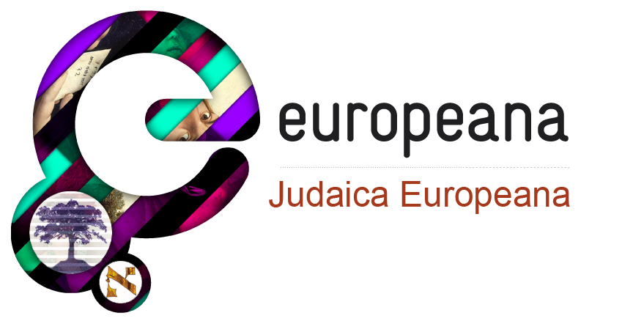

EVENT EVALUATION
Event: Judaica Europeana Digital Humanities Workshop at the IX Congress of the European Association for Jewish Studies

Location and Date: Palazzo Verdi, Ravenna, 30 July 2010

By Svenja Pokorny (Amitié)
August 2010

eContentplus
This project is funded under the eContentplus programme,
a multiannual Community programme to make digital content in Europe more accessible, usable and exploitable

Table of Contents

0. Context 3
1. Purpose of the report 3
2. Evaluation synopsis 3
Annex I: Evaluation form 7

0. Context
Judaica Europeana is a digital project co-financed by the European Commission eContentplus Programme to provide access to Jewish culture collections through Europeana, Europe’s archives, libraries and museums online. It is anchored in a network of leading European institutions with substantial content holdings that document Jewish contribution to the development of European cities.

The Judaica Europeana Workshop on Digital Humanities was held to provide an introduction for scholars to the repertoire of open source web-based research and teaching tools that are becoming a standard part of the toolbox of historians and other humanities researchers.

1. Purpose of the report
Event evaluation is an important follow-up mechanism within the adaptive management framework of Judaica Europeana. It pays attention to participant engagement and response. The following report will provide the partners and the European Commission with information on the quality of the Judaica Europeana Digital Humanities Workshop as perceived by the participants. It contains the lessons we have learned and should help us to understand:
- How the event went
- What people got out of it
- What we have learned
- Key factors for improvement

The event evaluation was carried out by the participants through the ‘Evaluation form’ (see Annex I), which includes the following criteria:
- Quality of content
- Quality of the location
- Quality of the speakers

2. Evaluation synopsis

This section analyses the responses to the Evaluation form distributed during the Judaica Europeana Digital Humanities Workshop at the EAJS Congress, held in Ravenna (IT) on 30 July 2010. A total of 11 completed forms were returned from a total registration of 24 people.

Rating Scale
A five-point scale was used to rate the quality of selected key aspects of the event (from 1=poor to 5=excellent).

 |  | Mean value
Content |  | (4.4)
Location |  | (4.1)
Speaker |  | (4.0)

Open questions
No answers or comments were excluded or edited.
In one sentence, please describe your thoughts on this activity with respect to its value for you.

- It was extremely helpful and eye-opening.
- Giving more order to my “Spontaneous” activity on the Web – the beginning of, hopefully, an important networking with very different scholars.
- Very useful.
- Established the bases for digital research and research sharing.
- Opening new fields of activity for scholars of humanities, good advice for newcomers to this area.
- I would be happy to cooperate with Europeana and bring my museum’s resources to its collection. I am seeking any hints how to do it.
- Excellent introduction to this subject.
- I shall start to publish my research results in a digital form.
- More information, more structure
- For the first time I could form a clear picture of the possibilities and things involved in preparing a web-based critical edition.
- The workshop addressed crucial questions of how to use the web for research in the humanities, and I have received much inspiration.

What could have been covered more quickly, what needed more time, and what wasn’t covered?
- It was very effective and well-balanced.
- Blank
- Blank
- Blank
- More time to [be given to] five examples for scholars with digitized projects already on the web, open source
- The process of digitisation was not covered at all – while this was THE thing that made me come here.
- The use of web tools in teaching such as Parmind needed more detailed presentation.
- Blank
- Blank
- The first part could have been quicker
- Could have been better presented. Also, the presenters were strongly biased towards a specific attitude towards web publishing (open access), which I do not share. Only actual authors of presentations should present, in order to avoid inability to answer questions from the audience. [one of the presenters was absent due to air strike]

Do you have any suggestions on how this activity could be improved?
- No
- It is an excellent introduction –next meetings could be longer and focus on one-two single cases. It would be advisable to sit at a round table.
- Blank
- Perhaps with the presentation of a specifically Judaic digital project.
- It has to be continued in small workshops within university and show very detailed how this will work
- I would like to hear much more real-life examples than pure theory which is not so much interesting
- If more time could be available, demonstrate a step-by-step setting-up of a collaborative research project on the web.
- Blank
- Longer workshop, more study-cases
- The acoustics of the room but that is something you could not really help – it’s the building.
- Blank

Other feedback or comments:
- Blank
- Concerning the use of the Web in teaching non-graduate students. It could be useful to draw few points – guidelines – recommendations regarding its honest use.
- Blank
- Blank
- Produce together prototype of tutorial, demo-version of a topic with modern technology
- Blank
- One of the speakers should speak more slowly.
- Blank
- A very important initiative!
- Excellent! Clear and good to follow for someone who is not so good in the technical aspects (like myself), thanks a lot
- Blank

Optional - Name:
- Ronit Yoeli - Tlalim
- Laura Mincer
- Blank
- Blank
- Blank
- Anna Lebet-Minakowska, Muzeum Narodowe w Krakowie (alebet@muzeum.krakow.pl)
- Blank
- Maria Micaninova
- Blank
- Johanna Tanja
- Blank

Most participants appear to have been extremely satisfied with the overall organization and implementation of the workshop.

The presentations were generally very well received and comments are enthusiastic and promising although there were a few criticisms. The acoustics of the high-ceiling room was one of the complaints mentioned by respondents. In terms of content, one participant wished for information on digitisation of museum collections, which is one of the objectives of the project, but not of the workshop. This misunderstanding can be easily solved via a direct contact with the interested person. The subject of on-line publishing was illuminating for some and controversial for others. There is quite an interest in the topic of collaborative on-line research and in participating in other similar workshops. Future events should include more practical guidance and real case studies or specific examples in Jewish studies.

I am pleased to report that the general consensus is that the 1st Workshop was a great success and a worthwhile experience for most participants. Thanks to everyone who contributed to achieve this welcome result.

Annex I: Evaluation form

Evaluation Form

Event: Judaica Europeana Digital Humanities Workshop at the EAJS Congress
Location and Date: Ravenna, 30 July 2010

Thank you for participating in this activity. Your feedback is important to us as it helps us improve what we do – we would appreciate if you could take a couple of minutes to evaluate today’s event.

How would you rate this event?
Content Poor  Average  Good  Very Good  Excellent 
Location Poor  Average  Good  Very Good  Excellent 
Speaker Poor  Average  Good  Very Good  Excellent 

In one sentence, please describe your thoughts on this activity with respect to its value for you.

What could have been covered more quickly, what needed more time, and what wasn’t covered?

Do you have any suggestions on how this activity could be improved?

Other feedback or comments:

Optional - Name:

Thank you for completing this evaluation
www.judaica-europeana.eu

OJ L 79, 24.3.2005, p. 1.

